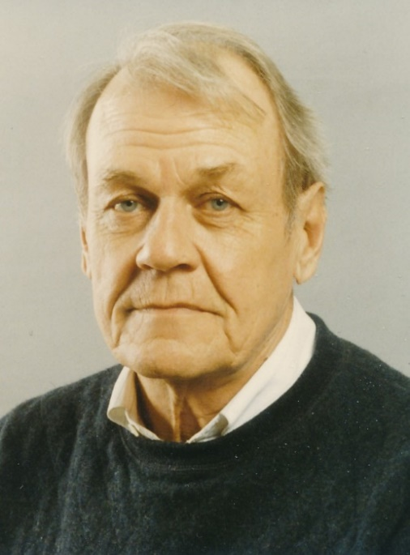

Dudley G. Luckett

Dudley Gilmore Luckett, Emeritus Professor of Economics and Emeritus Distinguished Professor in Liberal Arts and Sciences, died January 24, 2020, at Northcrest Health Center in Ames at the age of 91 years.

Dudley Luckett was born September 10, 1928, in Kansas City, Missouri, and grew up in Sedalia, Missouri. After graduating from high school in 1946, he joined the U.S. Army and served for two years, primarily with the U.S. occupation forces in Japan. Upon completing his military service, he enrolled in the University of Missouri where he earned an AB degree in political science in 1952 and the MA degree in economics in 1954. He then enrolled in the graduate program at the University of Texas (Austin) and was awarded the PhD degree in economics from that institution in 1958.

Dudley Luckett began his career as a member of the faculty in the Iowa State University Department of Economics in 1958. Initially appointed as an Instructor, he was promoted to Assistant Professor in 1959, to Associate Professor with tenure in 1962, and to Professor in 1964. He became a Distinguished Professor in 1985. He retired from ISU at the end of 1995.

Dudley Luckett’s primary area of professional interest was monetary economics. He taught courses in this area at both the undergraduate and graduate levels throughout his career at Iowa State. When he joined the faculty in 1958, only one section of the undergraduate course in Money and Banking was offered each academic year and it had only a modest enrollment. When Luckett began teaching this course, the enrollment increased rapidly and within just a few years, the course had multiple sections offered each year and the largest enrollment of all upper-level courses in the department. He wrote an undergraduate textbook, Money and Banking, which was published by McGraw-Hill in 1976 and was adopted for use by a large number of universities in the U.S. and abroad. A second edition of the book was published in 1980 and a third in 1984. A modified version of the book was also published in Indonesia.

At the graduate level, Luckett taught Advanced Money and Banking, which provided a critical part of the department’s PhD field of concentration in Monetary Economics. This field was the department’s largest and most successful general economics field during the 1970s and 1980s.
Luckett also taught courses dealing with the history of economic thought at both the undergraduate and graduate levels on a regular basis. He received the University’s Outstanding Teacher Award in 1978.

During his years at Iowa State, Luckett served as major professor for 28 PhD students and 13 MS students. Many of his PhD students had very successful careers in academia and/or government service.

Dudley Luckett was a scholar of widespread repute. His first two refereed journal articles appeared in top-tier economics journals and received recognition within both the academic community and the professional finance community. Subsequent journal articles added to his reputation as an accomplished and pioneering scholar. In 1964, he was selected to be an Associate Editor of the Journal of Finance, the journal of the American Finance Association. In 1967, he accepted a four-year appointment as Managing Editor of this journal.

Luckett developed an interest in the economics of lesser developed countries in the latter years of his academic career. In 1983, he received a Faculty Improvement leave from Iowa State to conduct research in Fiji. This resulted in a book, Monetary Policy in Fiji, which was published in 1987 by the Institute of Pacific Studies at the University of the South Pacific. He took a two-year leave of absence in 1987 to serve as a visiting professor at the National University of Singapore. This resulted in another book, Banking, Finance and Monetary Policy in Singapore, co-authored with David Schulze and Raymond Wong and published in 1994. In 1994, he received a Fulbright Research Grant for a study of the multi-country Eastern Caribbean Central Bank.

Dudley Luckett is survived by his daughter Elaine Rees Luckett, by his sons Luther James Luckett, Thomas Manley Luckett, and Brian Gilmore Luckett, and by six grandchildren.

Respectfully Submitted by Dennis R. Starleaf and Lehman B. Fletcher

