**Patently Risky: Framing, Innovation and Entrepreneurial Preferences**

Elizabeth Hoffman • David Schwartz • Matthew Spitzer • Eric Talley[1]

September 3, 2018

**Abstract:** Innovation policy balances static monopoly rights against dynamic entrepreneurial incentives. In understanding this balance, researchers and legal actors commonly presume that decision makers in innovative settings react to their economic environments in a manner similar to their counterparts in other contexts. This paper presents experimental evidence to the contrary. Subjects were offered a choice between a sure thing and a risky choice, where our principal manipulation was to alter the decisional frame. Subjects in the control group confronted an unadorned choice between safe and risky options; subjects in the treatment group, in contrast, were told that the risky choice was tantamount to an investment in an innovation-related project. In all other respects, we controlled for both the language of the experimental instrument as well as the economic stakes entailed. In some subgroups, the risky choice also included a potential monetary loss. We administered the experiments across three subgroups of settings/subjects: a brick-and-mortar lab using university students, an Internet protocol again using university students, and an Internet protocol using Mechanical Turkers as subjects. Our main result, which appears quite strong and robust, is that our manipulation induced subjects to manifest greater degrees of risk tolerance on average, across all three settings, and across specifications involving positive and negative payoffs. We calibrate our results to an estimate of a downward “shock” that the experimental manipulation introduces to subjects’ coefficients of relative risk aversion, benchmarking our results against Holt and Laury’s (2002) risk-aversion elicitation scale.

**Keywords** Risk aversion; framing; patents; intellectual property; entrepreneurship.

**JEL Codes** C9; C92; L2; L26; K1; O34.

1. **Introduction**

It has long been known that patent law and policy must navigate a precarious trade-off between static monopoly on the one hand, and dynamic incentives on the other. By offering the prospect of monopoly rights over inventions (a static “bad”), patent law provides incentives for would-be inventors and entrepreneurs to develop new product markets and improve old ones (a dynamic “good”). These competing concerns stake out polls of a delicate balance that can be challenging, in practice, to reconcile. Intellectual property (IP) institutions are charged with the task of providing sufficient incentives to catalyze socially valuable innovations, but they must also take care not to over-incentivize such efforts by promising IP rights that are too capacious, too long-standing, or too preclusive of successors’ efforts (Heller and Eisenberg, 1998).

Consequently, a critical input into a defensible IP policy is knowledge of how and when incentives work in entrepreneurial contexts. Among economists, it is natural to presume that prospective inventor-entrepreneurs respond to incentives and risks in a manner that is similar to other economic actors, blending risk preferences, marginal utilities, and subjective probabilities in predictable ways. That presumption—while seemingly sensible—is clearly critical: for if the innovation context changes decision-making behavior in a manner diverging from other contexts, an efficiency-minded IP policy would need to take such changes into account when striking the balance between monopoly and incentives.

This article reports some simple experiments demonstrating that individual decision-making behavior *does*, in fact, shift in contexts that involve innovative entrepreneurship. Our experimental inquiry produces one striking result, and several others that are less striking but also of interest. In each experimental setting, we confronted subjects with a choice between a sure thing and a risky choice. Our principal manipulation was to vary the frame of this choice. In the *invest in invention frame*, subjects were told they could either keep their sure thing payoff, or invest it in creating a hypothetical invention with risky (but actuarially attractive) payoffs. In the *simple lottery* *frame* we gave the subjects the same substantive choices (with identical payoff structures), but one that stated an unadorned choice between a safe and a risky option, bereft of other framing. Each of the two frames fully specified and controlled for the risk attributes of the lotteries. Beyond the simple frames, we used exactly the same language to describe the lotteries. We administered the experiments in a brick-and-mortar lab at Iowa State University, over the Internet using Iowa State students as subjects, and over the Internet using Amazon’s Mechanical Turkers (M-Turkers) as subjects.

The striking result, which appears quite strong and robust, is that our experimental manipulation induces significantly greater risk tolerance among subjects in all three settings. These results hold up regardless of whether we control for the subject’s age, gender, ethnicity, and several metrics of stated risk aversion. The results also persist when subjects face the prospect of a potential negative payoff associated with the risky project. The results lose statistical and economic significance when subjects are presented with only the word “invest” without “invention,” further supporting the interpretation that the word invention, alone or in combination with word invest, is driving our results. We calibrate our results to an estimate of a downward hedonic “shock” that the manipulation introduces to subjects’ manifest risk aversion, benchmarking against Holt and Laury’s (2002) results. Because the effects of the Invest in Invention frame continue to hold even in the presence of negative payoffs, our results contrast with (though do not directly contradict) the predictions of Kahneman and Tversky (1979), who find that preferences in the presence of negative payoffs (relative to a reference point) behave fundamentally differently from those with strictly positive payoffs.

A secondary result is that—consistent with other literature—the M-Turkers are not strictly comparable to the student subjects across several dimensions. Most notably, in addition to their demographic differences, M-Turkers manifest greater risk aversion, regardless of frame, than students on the Internet and in the Lab. A related result pertains to the utility of M-Turk subjects more generally. Although there are many papers exploring whether results on M-Turk are different from those in the lab, there have been none (that we can find) that consider the sort of framing that we utilize. Our results preliminarily confirm that—despite their various observable differences from conventional subjects—M-Turkers can be used successfully to test the types of framing manipulations at issue here.

1. **Literature Review**
   1. **Intellectual Property**

Intellectual property (IP) broadly includes patents, copyrights, trademarks, and trade secrets. For our purposes, patents are the most relevant, followed by copyrights which are of some relevance. Patents basically protect functional inventions. They are awarded by the government to inventors of new, useful, and non-obvious inventions. Copyrights, which are justified on the same economic theory, protect original works of authorship such as books and music. Because some of the copyright literature is potentially extendable to patents, we discuss both the patent and copyright (more broadly, intellectual property) literature in this section.

There are several places in the intellectual property literature in which incentives and risk preferences matter. Below, we set forth two broad categories.

* + 1. ***Motivation for Inventing and Creating****:*

There is a literature in economics, as well as in sociology and psychology, that attempts to explain why individuals and firms generate new creative and innovative works. The classic economic theory is that incentives such as the limited exclusive rights offered by patents are necessary to properly encourage the generation of new works. The economic theory has two parts. First, even if innovation had no risk, inventors would face the problem of copying (Lemley, 2005). Once an inventor has spent the time and effort needed to produce the innovation, others will copy it and compete against the original inventor. In this way, the value of the innovation will be driven down to (almost) nothing. Anticipating copying, the inventor chooses not to innovate. Patents prevent such copying and thereby protect innovation. Second, of course, innovation is actually quite risky and the need to provide incentives, such as patents, is predicated on the view that individuals will choose to avoid risky enterprises. Arrow (1962) has suggested that risk-aversion may lead to under-investment in invention. *Id*. According to this theory, the exclusive rights provided by the patent system help individuals overcome the risk aversion-induced market failure and innovate in ways that are socially desirable. This basic economic theory has been adopted by the United States Supreme Court. In *Kewanee v. Bicron Oil*, 416 U.S. 470 (1974), a well-known case that discussed the purposes of intellectual property law, the Supreme Court remarked: ““[t]he patent laws [offer] a right of exclusion for a limited period as an incentive to inventors to risk the often enormous costs in terms of time, research, and development.”

Outside of financial incentives provided by patents, the literature sets forth other motivators of innovation, including reputational effects, career rewards, and other intrinsic motivations (Lach and Schankerman, 2008). Similarly, employees within a firm may be motivated by opportunities for promotion rather than direct benefits from patenting. In addition to the financial rewards, reputational effects, and career rewards, innovation may be due to other intrinsic motivations. For instance, some individuals enjoy solving puzzles (Lam, 2011). Puzzle solving may lead to innovation, and it provides intrinsic satisfaction and motivation to some individuals (Lam, 2011; Silbey 2015). For most commercial development of new works, there are a variety of reasons why individuals and firms innovate. *Id.*

* + 1. ***Risk Preferences of Individuals and Firms with Respect to Creating***:

There is little solid empirical or experimental evidence on the risk preferences of individuals and firms in the innovation ecosystem. The majority of the IP literature *assumes* that creators and inventors are risk-averse, although a minority of scholars assert the opposite, namely, that creators and inventors are risk-seeking.

Joseph Stiglitz, when discussing intellectual property, articulates the classic view that “[p]eople and firms are risk averse, and if they have to bear risk, they have to be compensated for doing so” (Stiglitz, 2008). Under this view, potential creators and others in the innovation system suffer from risk-aversion like regular people. Without the financial rewards of the patent and copyright systems, societally sub-optimal levels of creative works will be produced. Steven Horowitz makes a similar claim about copyright, arguing that copyright holders are “risk averse, valuing clear entitlements more than equivalent murky ones” (Horowitz, 2012).

Relying on the American mineral system for public lands, in 1977 Edmund Kitch propounded the prospect theory of patents, which claims that patent rights are useful in channeling and coordinating development activities in a new technology. By awarding exclusivity shortly after invention, prospect theory asserts that the patent system provides the first inventor with an incentive to develop the broad field of invention (Kitch, 1977). Other scholars note that prospect theory assumes a risk-averse inventor who needs strong property rights to be incentivized to develop the field (Ghosh, 2004).

On the other hand, some scholars assert that inventors and creators are risk-seeking. F.M. Scherer offered the “lottery theory” of patents, arguing that patents are like lottery tickets, with most patents being essentially worthless while a small minority of them have substantial value (Scherer, 2001; Crouch, 2008). Building upon Joseph Schumpeter’s theory that investors overestimate their chances of success when presented with a potentially great reward, Scherer posited that potential inventors are sufficiently incentivized to create new inventions by the tiny chance of a large payoff from a patent. Gideon Parchomovsky and R. Polk Wagner note that “the lottery theory critically depends on the assumption that inventors, like lottery ticket buyers, are risk-seeking—indeed, so risk-seeking that they are willing to engage in an activity with a negative expected value” (Parchomovsky and Wagner, 2005). They argue that corporations, rather than firms, pursue most patents and assert that “the decisions of corporate managers appear both rational and even risk-averse” (Parchomovsky and Wagner, 2005).

There is little reliable data on this issue of risk tolerances relating to intellectual property, and most of it is inconclusive (Sawicki, 2016). Perhaps the best study is by Thomas Astebro (2003). Astebro studied a sample of approximately 1,000 Canadian inventions that had been evaluated before commercialization by a non-for-profit organization, the Canadian Innovation Centre (CIC) (Astebro, 2003). Astebro surveyed the inventors many years after the CIC evaluation to learn whether they had commercialized after receiving the CIC evaluation, and if so, what the return on investment was. He reported that independent inventors develop and commercialize inventions that have *negative* expected returns. These individuals attempted to further develop inventions when their time and money would have been better spent elsewhere. Astebro concludes that “risk-seeking is one of several plausible reasons why so many inventors proceed to develop their inventions while only a small fraction can reasonably expect to earn positive returns on their efforts. Another plausible explanation is that inventors are unrealistic optimists in that they overestimate their abilities to succeed” (Astebro, 2003).

The literature on risk-aversion sometimes divides the risk into risk of failure of creation and risk of liability for infringement. Turning to the risk of liability for patent infringement, Robert Merges points to “risk-aversion” as the reason a potential patent infringer may pay a higher rate or fee for a license than justified by a traditional economic analysis (Merges, 1988). Jeanne Fromer makes a similar argument not about the royalty rate but about entering into licenses in the first instance. According to Jeanne Fromer, competitors take patent licenses because they are risk-averse about potential liability (Fromer, 2009).

In the copyright literature, Jim Gibson (2007) writes that “the decision-makers in the real world of copyright practice are typically risk-averse.” Jim Gibson argues that new copyrightable works require “high upfront investment” and only a “prospect” at profits, which apparently refers to the risk of failure of creation. *Id.* But Jim Gibson ties the risk-aversion to liability for infringement, saying that decision-makers “approach legal issues very conservatively, particularly issues like copyright liability, which have the potential to delay or even destroy the entire project.” *Id.* Jeanne Fromer (2012) also believes that fear of copyright liability causes particular problems because authors are risk-averse. She states “risk-averse authors might frequently avoid modifying works in ways that ought to be construed as fair uses or secure an unnecessary license authorizing this modification.”

A recent article by Andres Sawicki (2016) nicely explains the state of the research into risk tolerances relating to intellectual property. While noting the empirical evidence is often inconclusive and scant, he hypothesizes that creators have a greater tolerance for risk than the general population. He also reasons that creative individuals prefer risk rather than certainty, and that riskier environments are more conducive to creativity than less risky ones. Sawicki theorizes how risk preferences of creators might affect which form of incentive – patents and copyrights, prizes, grants, and tax credits – would be societally optimal. But all of this is surmise. As Sawicki, himself, emphasizes, there is little empirical evidence.

* + 1. **Prior Experiments on Intellectual Property**

Our invest in invention frame directly references an *invention*. There are some relevant works, but none of them preempts our study. There are several prior experimental papers on intellectual property law, many of them by Christopher Buccafusco, Christopher Sprigman and various coauthors, (E.g. Buccafusco and Sprigman, 2010, 2011; Buccafusco, Burns, Fromer, and Sprigman, 2014; Buccafusco and Heald, 2013; Bechtold, Buccafusco, and Sprigman, 2015; Buccafusco, Bechtold, and Sprigman, 2013; Sprigman, Buccafusco, and Burns, 2016; Buccafusco, Heald, and Sprigman, 2017). These experiments are aimed at figuring out how people respond creatively to various types of incentives, and how they value and trade the IP once it is created.

The closest experiments to our own are probably Buccafusco and Sprigman (2010, 2011), who ran a series of experiments designed to test for the existence and size of the endowment effect in intellectual property rights. They find, in general, that the endowment effect is huge for the rights to a prize for a winning poem or painting. However, the Buccafusco and Sprigman papers, while very valuable in their own right, do not preempt ours. First, they test for bids and offers for a prize in a copyright context, not the decision to *invest in an invention*. Second, their endowment effect frame is fundamentally different from ours. See the discussion, below, in our section on framing. Third, they do not test for the difference between laboratory experiments and M-Turk. There is at least one prior work using M-Turk for an IP experiment by Buccafusco, Heald, and Bu (2016). However, we have found no prior work testing for the *difference* between a brick-and-mortar laboratory and M-Turk in any IP experiment.

There are a number of other important experimental works on IP. For example, Buccafusco, Burns, Fromer and Sprigman tests the different incentives provided by copyright and patent on creativity.[2] Several prior works have focused on sequential innovation – the problem of needing to get permission to use prior, protected works in creating new works. The first, Torrance and Tomlinson (2009), was an extremely complicated, multiple stage game. Some subsequent experiments have been less complex, Bechtold, Buccafusco & Sprigman (2016), Brueggermann et al, (2015) and suggest that IP rights in a first invention hinder sequential innovation, although Bechtold, et al, obtain results partially *inconsistent* with inventor rationality. Others, such as Boudreau and Lakhani (2013), suggest that a *lack* of rights in a first invention, as against sequential invention, discourages the initial invention.

In sum, although there are a number of interesting works at the intersection of IP and experimental methods, but there is nothing that we have found that addresses the issues covered in our paper.

* 1. **Framing**

Our experiments rely on a “frame.” However, in the literature, *frame* means several different things. In order to situate our paper in the literature, we must briefly review some of the previous papers that synthesize categories of frame.

* + 1. ***Previous Categorizations of Frames***

There are already some categorization schemas in the political science and psychology literatures. For example, Druckman (2001) contrasts *equivalence* framing– “the use of different, but logically equivalent, words or phrases (e.g., 5% unemployment or 95% employment, 97% fat-free or 3% fat) causes individuals to alter their preferences,” with *emphasis* framing effects, which “lead the subject to focus on one aspect of a problem, thereby affecting his opinions and preferences.” Banerjee and Chakravarty (2012), on the other hand, contrast *label* framing, invoked “if subjects are confronted with alternative wordings, but objectively equivalent material incentives and unchanged reference points (with regard to how the endowment is initially allocated)” with *value* framing, where “subjects are confronted with alternative wordings and objectively equivalent material incentives but changed reference points.” Levin, Schneider and Gaeth (1998) contrast *risky choice* framing (similar to value framing) with *attribute* framing, where “people are more likely to evaluate a gamble favorably when it is described positively in terms of winning rather than when it is described negatively in terms of losing,” and *goal* framing, in which, not surprisingly, “the goal of an action or behavior is” described differently.

Unfortunately, none of these categorizations relates sufficiently precisely to our treatment. Thus, we synthesize the literature into three broad categories.

* + 1. ***Light Computation***:

First, there are frames which require light computation by subjects to understand that the choices they have are equivalent. These include the “reference point” frames for which Kahneman and Tversky (1981) are most famous. This category also includes circumstances where frames induce asymmetric errors in understanding games (Fosgaard et al., 2016). There are also experiments that use compound lotteries. For example, Abdellaoui, Kilbanoff, and Placido (2015) measured compound risk and found that subjects valued compound risks differently than simple risks and that the risk attitudes displayed “more risk aversion as the reduced probability of the winning event increases.” There is also a fascinating paper by Brooks, Stremitzer and Tontrup (2017) which studies *effort* participants exerted when they entered into a contract and completed monetarily incentivized economic tests. The authors determined that thresholds and framing affect effort, noting particularly that loss framing with “poorly selected thresholds may reduce effort” (pg. 1) But none of these versions of light computation correspond to the type of frame we used.

* + 1. ***Emphasis and Priming***:

Second, there are frames that emphasize one aspect, or another, of a choice in a negative or positive light. An excellent example comes from Chong and Druckman (2007) at 104:

What is particularly vexing in public opinion research is a phenomenon known as “framing effects.” These occur when (often small) changes in the presentation of an issue or an event produce (sometimes large) changes of opinion. For example, when asked whether they would favor or oppose allowing a hate group to hold a political rally, 85% of respondents answered in favor if the question was prefaced with the suggestion, “Given the importance of free speech,” whereas only 45% were in favor when the question was prefaced with the phrase, “Given the risk of violence.”

In this sort of frame, there is no real difficulty or mental computation required in understanding the basic choice of allowing a hate group to hold a rally or not. The frame, instead, prompts the subject to concentrate on either a positive aspect (the value of free speech) or a negative aspect (the risk of violence) inherent in the choice. Emphasis frames seem to us very close to *priming*. Priming, in psychology, is giving a subject some information that triggers a particular emotional reaction, or which focuses attention on some aspect of the experiment.[3] Thus, a recent article “primes” experimental subjects (all of whom were financial professionals) with either a boom or a bust scenario. (Cohn, 2015) Those who were primed with a bust scenario became more risk averse. But one could just as easily say that the subjects were in a bust frame, where the frame is an emphasis frame.[4] Priming, rather than framing, tends to be used in experiments involving financial decision making and risk acceptance. See Erb, 2002; Mandel, 2003; Meier-Pesti and Penz, 2008.[5] Again, this does not seem to correspond to the frame in our paper.

* + 1. ***Imagine Yourself in a Context***:

Finally, Imagine Yourself in a Context frames are found in experiments that either tell subjects that they are in a particular setting, or ask the subjects to imagine themselves in a particular setting when making choices. These experiments often involve risky choices, and particularly those experiments looking for the source of differences between men’s and women’s attitudes towards risk. Schubert, et al (1999); Eckel and Grossman (2008); Fehr-Duda (2006); Lotz (2015); Charness and Gneezy (2012). In these frames the subjects are prompted to imagine themselves in a casino, or imagine themselves buying insurance, or imagine themselves making an investment. In some of these papers the context, interacted with gender, produces a change in risk aversion.[6] The exact mechanism is unclear. It could be that subjects have different utility functions in different contexts, or perceive probabilities differently in different contexts (e.g. casino v. insurance) or it could be that the frames prime different emotions that in turn change behavior.[7]This is, in essence, the nature of the frame we used in our experiment.

1. **Description of Experiment**

The most fundamental question we consider in our experiments is whether subjects manifest different risk preferences when a risky choice is framed as a simple lottery versus investing in an innovative technology. For convenience here, we refer to these as our “Simple Lottery” frame and our “Invest in Invention” frame. The language of our “Invest in Invention” frame is:

*“Before filling out a brief questionnaire, you will be given $8 either to* ***Keep*** *or to* ***Invest*** *in creating a hypothetical invention . . . . If you choose to* ***Keep****, your earnings will be $8. If you choose to* ***Invest*** *there is a 1/3 chance that the creative and commercialization process will be successful and return $30, and a 2/3 chance that it will be unsuccessful in the market and return $3. A role of a die will determine your earnings, either $30 or $3.” [Emphasis in original.]*

We are closest to the “Imagine Yourself in a Context” version of framing, albeit with real economic stakes. In the Invest in Invention frame, we inform subjects that they have the opportunity to invest in a “hypothetical invention.” The payoffs correspond to whether or not the invention succeeds and is a success in the market. Beyond the (accurate) financial rewards, clearly none of this is true. Instead, by being prompted that this is a hypothetical invention, the subjects are being asked to imagine that it is true, and act accordingly.  We used the adjective “hypothetical” to describe the invention to reduce the chance that subjects felt that the invention was exciting or prosocial. We believe that labeling it as a hypothetical invention should moderate the effect of the word “invention” on subjects, making any findings to be conservative estimates of the true effects of “invention.”

Our frame is clearly not a light computation frame, similar to the reference point frame used by Kahneman and Tversky (1981). Our gambles are stated in absolutely identical terms. And, just as in the other papers that use this frame, we assume that the subjects are imagining in precisely the way that we ask of them.

In the Simple Lottery frame, we tell subjects the following:

*“Before filling out a brief questionnaire, you will be asked to make a choice between* ***Option A*** *and* ***Option B****. You will have only a single opportunity to choose. After you have made your choice, if you chose* ***Option A,*** *your earnings will be $8. If you chose* ***Option B****, there is a 1/3 chance that your earnings will be $30, and a 2/3 chance that your earnings will be $3. A role of a die will determine your earnings, either $30 or $3.”*

Note that the Simple Lottery frame and the Invest in Invention frame describe exactly the same percentages and payouts.

We used a simple, binary choice at the center of this experiment for two reasons. First, anticipating that we would be running our experiment on MTurk, and knowing that MTurk subjects present a far different profile from brick-and-morter subjects in the lab (see Paolacci & Chandler (2014) (e.g., MTurkers averaged 35 years of age, while lab subjects averaged just over 20 years of age), we wanted to keep the choice simple and intuitive (Dave et al., 2010). The alternative would have been to use something like the choice in Gneezy and Potters (1997). In Gneezy and Potters (1997) at page 634, they implemented the following choice. The subject was given 200 units (convertible to cash at the end of the experiment), and then offered the choice to allocate X, where 0 ≤ X ≤ 200, to the following gamble. The subject has a 2/3 chance of losing the amount of his “bet,” X, and a 1/3 chance of winning 2.5 times X. If the subject allocates less than 200 to the gamble, he gets 200 – X with certainty, plus the outcome of the gamble. For highly numerate subjects, such an approach might provide more fine-grained information on attitudes towards risk. However, this choice is sort of complicated, and with our MTurk subjects we feared generating a great deal of noise.

Second, we used the simple, binary choice because we feel it captures some of the features of the external world in ways that more complex and nuanced choices do not. When someone is asking himself, “should I invest this money or keep it?”, he is far more likely to approach this question as binary, at least as a first step. And there are many situations, possibly as a result of mental accounting (Thaler, 1999; Langer and Weber, 2001), where binary choices are made. Thus, a binary choice is useful. None of this is to say that a more complex, continuous choice approach is not also relevant to understanding behavior. If one were trying to model someone who is deciding on a large number of investments as a portfolio, a different approach would be needed.[8]

In addition to choosing either ***Option A*** or ***B*** or ***Keep*** or ***Invest in Invention***, each subject provided answers to both a series of demographic questions (related to age, gender, education, and the like), as well as the Holt and Laury (2002)[9] risk aversion scale, generating a risk aversion parameter interval for each subject. Cox and Harrison (2008) summarizes the literature on estimating risk aversion up to 2008.

We first conducted a series of the above experiments in the lab at Iowa State University, using Iowa State students as subjects. The data were collected on a paper form and subjects were paid one at a time after an individual roll of a die to determine the payoff for those who chose the risky option. Students were randomly assigned to either the Simple Lottery or the Invest in Invention frame and the order of presentation of the certain and the risky options were randomly presented as either the first or the second option.

We replicated the first set of experiments on the M-Turk platform, using a Qualtrics format to collect the data and roll an electronic die. M-Turk subjects were paid in experimental dollars that converted to ¼ the lab payoffs. We reduced the payoffs to be more consistent with M-Turk payoffs. We do not believe that lowering the stakes should affect our results. See Gibson and Johnson (2018) (finding that preferences are preserved online and with small stakes when compared to other published experimental results).

Then, we replicated the experiments using a Qualtrics survey emailed to Iowa State students and conducted entirely online. Subjects chose to be paid by Amazon gift card, PayPal, or a check. The payoffs were expressed in experimental dollars that converted to ½ the lab payoffs.

We replicated the Mechanical Turk (M-Turk) and Online experiments with the possibility of negative payoffs (-$3 and +$42). For the negative payoffs iterations, **Option A** or **Keep** provided earnings of $8. For **Option B** or **Invest in Invention**, we informed subjects that “there is a 1/3 chance that your earnings will be $42, and a 2/3 chance that your earnings will be -$3….These earnings or losses will be added to or subtracted from your $5 participation fee.”

Finally we replicated the Mechanical Turk experiments with a modified Invest frame. We used the “can’t lose money” language for these experiments. In these series of experiments, we changed the Invest in Invention frame to remove the language about “hypothetical inventions.” Instead, the subjects were merely told “*you will be given $8 either to* ***Keep*** *or to* ***Invest*** *….*”

The number of subjects in each version is listed below.

|  |  |  |  |
| --- | --- | --- | --- |
|  | **Laboratory** | **Mechanical Turk** | **Qualtrics Online** |
| Invest in Invention Frame—Can’t Lose $ | 51 | 201 | 58 |
| Simple Lottery – Can’t Lose $ | 49 | 284 | 60 |
| Invest in Invention Frame – Can Lose $ | 0 | 98 | 78 |
| Simple Lottery – Can Lose $ | 0 | 104 | 80 |
| Invest w/o Invention Frame – Can’t Lose $ | 0 | 94 | 0 |
| ***Subtotal*** | 100 | 781 | 276 |

**Table 1: Number of subjects in each version**

[insert section defining collected variables, then table explaining how many of each]

|  |  |
| --- | --- |
| **Collected Variables** | **Description** |
| Turk | Dummy =1 if subject has completed the experiment on Amazon Mechanical Turk |
| Age | Subject’s age |
| Gender | Dummy=1 if subject is male |
| Hand | Dummy=1 if subject is left-handed |
| Ethnicity | Dummy=1 if subject is non-white |
| Gambled | Dummy=1 if subject has gambled for fun before |

**Table 2: List of variables and descriptions**

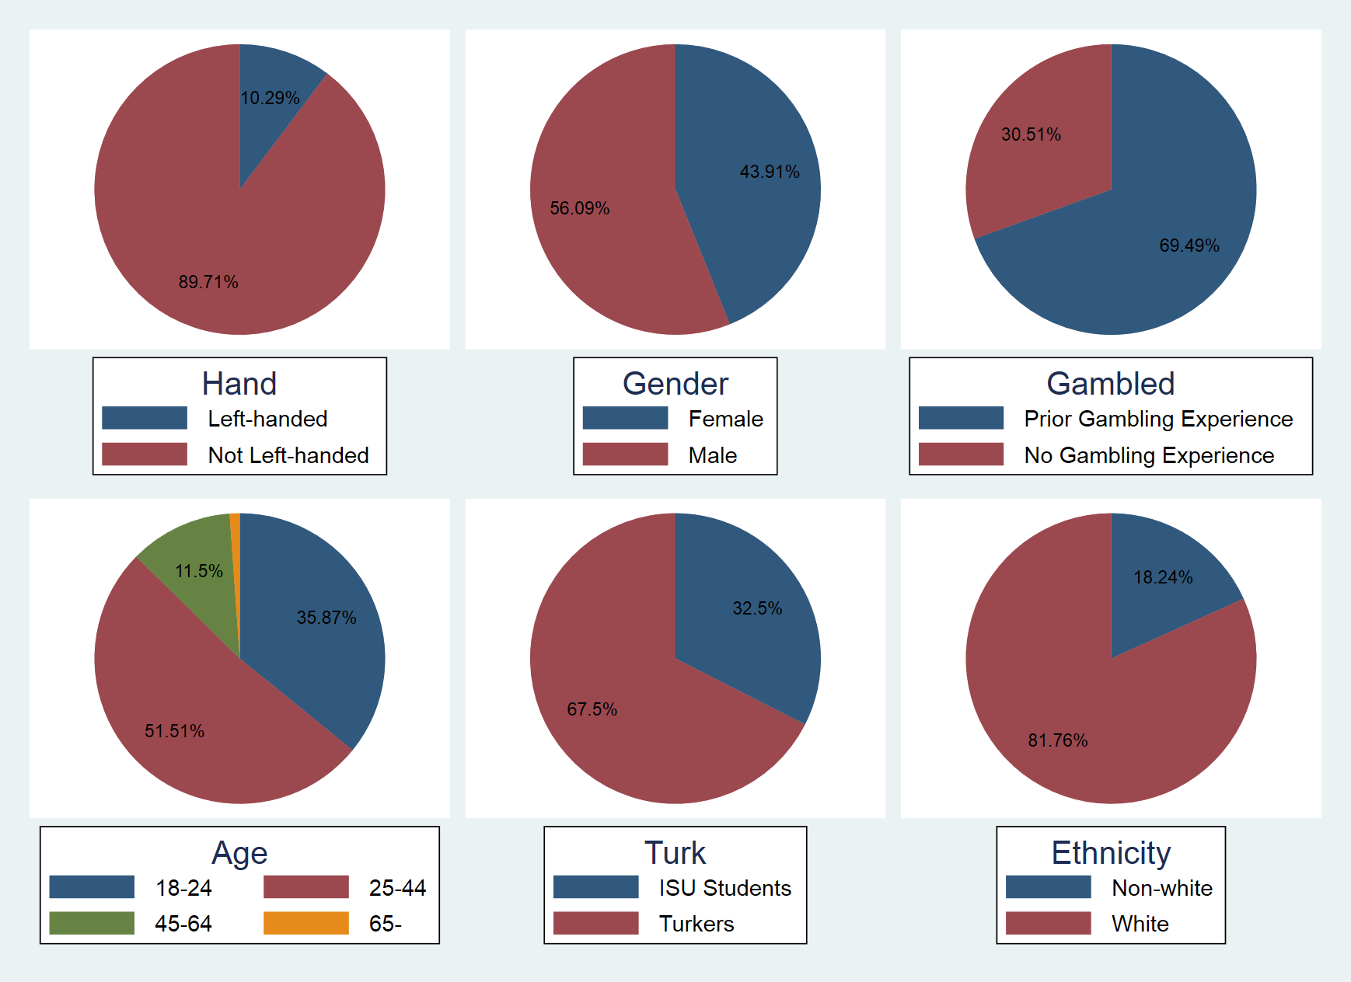

**Figure 1: Pie charts for the variables**

|  |  |  |  |
| --- | --- | --- | --- |
| **Variables** | **Responses** | **Frequency** | **Percentage** |
| Gambled | Gambled for Fun Before | 804 | 69.49 |
| Never Gambled for Fun | 353 | 30.51 |
| Ethnicity | White | 946 | 81.76 |
| Non-White | 211 | 18.24 |
| Hand | Right-Handed or Ambidexterous | 1,038 | 89.71 |
| Left-Handed | 119 | 10.29 |
| Gender | Female | 508 | 43.91 |
| Male | 649 | 56.09 |
| Age | 18-24 | 415 | 35.87 |
| 25-44 | 596 | 51.51 |
| 45-64 | 133 | 11.5 |
| 65 and Older | 13 | 1.12 |
| Turk | ISU Students | 376 | 32.5 |
| M-Turkers | 781 | 67.5 |

**Table 3: Number of subjects by variables and responses**

1. **Results**

Our primary results are shown in Figure 2 below. Basically, we find that subjects in the Invention Frames elect the sure thing less frequently in the treatment than the control.

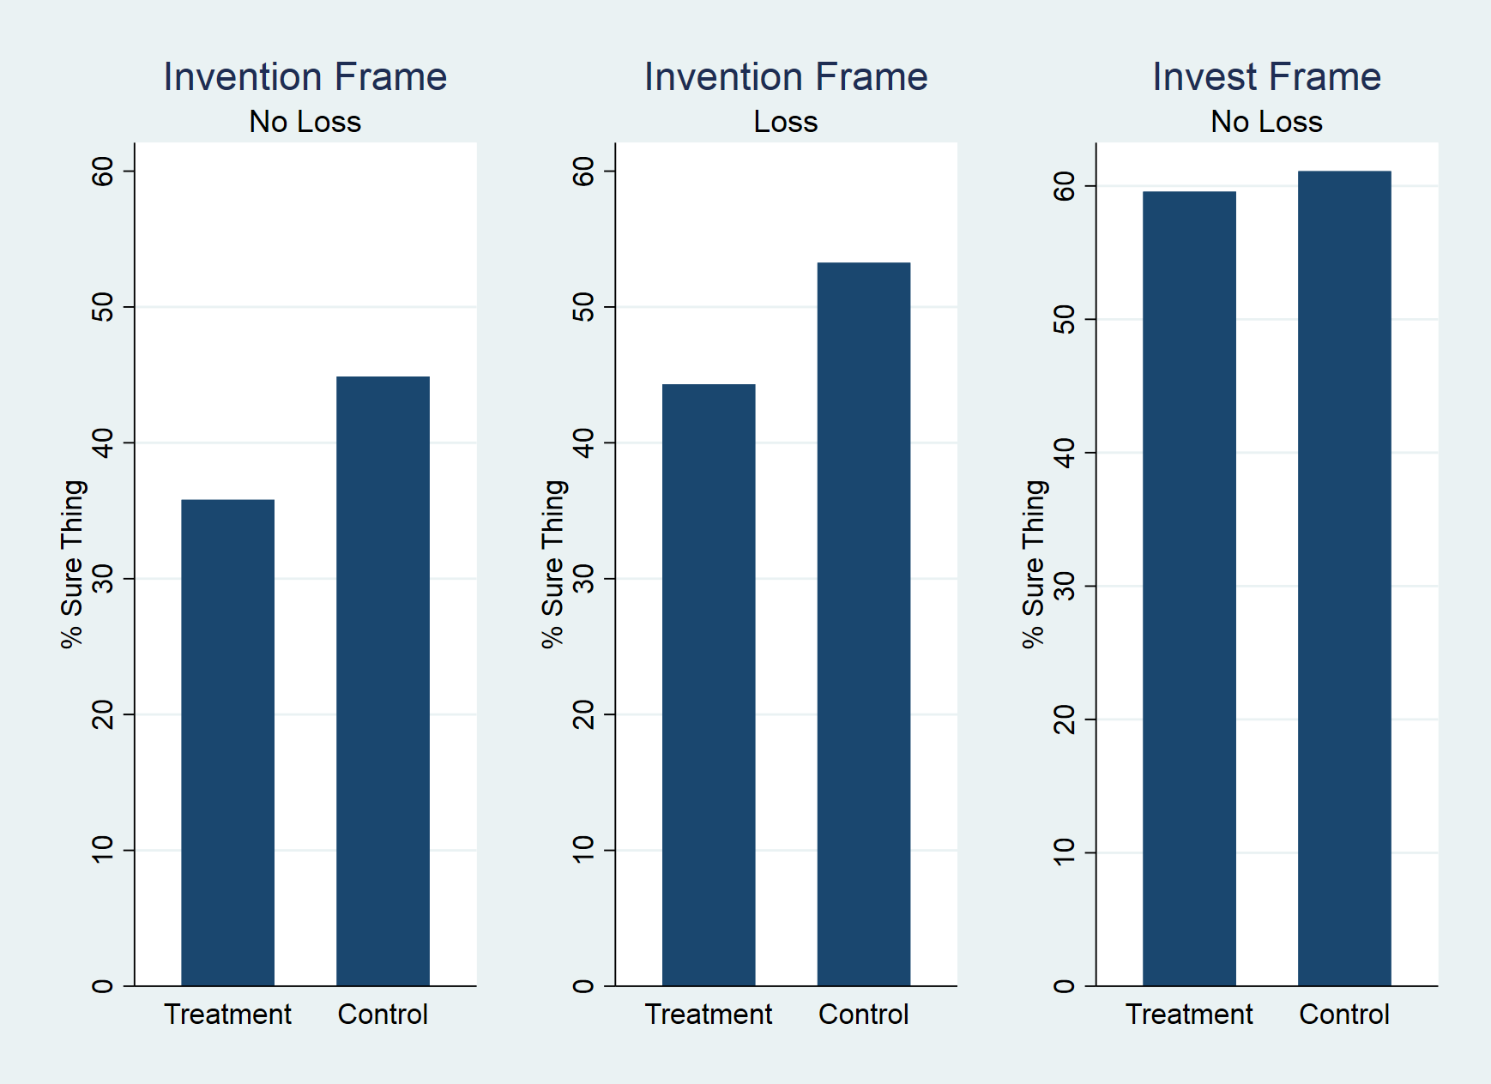

**Figure 2: Percentage of subjects choosing the sure thing by frame**

Our identification strategy hinges on detecting whether the experimental manipulation – *i.e.,* introducing the innovation/Invest in Invention frame – shifts subjects’ degree of revealed risk aversion in the way posited above, causing them to embrace a risky choice more readily than they would in the absence of the manipulation. In the parlance of the above notation, we are attempting to control for subjects’ baseline risk aversion parameter ($α_{0}$) and other demographic variables ($X_{i})$, and estimate the local average treatment effect of a downward shock ($λ$) that the experimental condition introduces (i.e., revealed risk aversion goes down in the presence of the manipulation).

We suppose that the relevant population exhibits CRRA preferences scaled by a (type dependent) CRRA risk aversion parameter $α\left(X_{i}\right),$ so that:

${α\left(X_{i}\right)=α}_{0}+β∙X_{i}+ε_{i},$

The only difference from the above is that we now introduce a statistical noise term $ε_{i}$, which we assume to be have zero mean and to be distributed according to the cumulative distribution function for the population, $Φ(ε_{i})$. A natural parametric assumption given the structure of our data is that εi is normally distributed (implying a Probit specification); but it easily confirmed that a variety of other distributional assumptions for Φ(.) work as well.

In proceeding, it is important to remain mindful of whether our experimental data on risk preferences is comparable to that found in the prior literature more generally. We could deploy this literature in two ways. Under the first (a “bootstrapping”) approach, we would use the baseline preference parameter estimates from pre-existing studies to impose similar structural constraints on the risk preference distributions of our own subjects. Under the second, we would use the results of the literature as a rough benchmark of comparison for our own sample of subjects, but then (after satisfying ourselves as to rough comparability) use our subjects’ own behaviors to identify the distribution of preferences. The advantage of the first approach is that it facilitates comparability of our results to the existing literature. The advantage of the second approach is that it allows us to control for an assortment of variables (e.g., demographic differences) that might be predictive of risk aversion but not easily observed in summary statistics reported in the existing literature.

We employ the latter approach. In Appendix A, we first confirm that our experimental data appear comparable to what has been found in prior literature, focusing particularly on Holt and Laury (2002) (hereinafter, designated HL) as a benchmark; and second, assuming our experimental control group data are comparable, we proceed to use those data as a baseline for teasing out the effect of our manipulation.

The tables below contain the ordinary least squares results of both (a) our baseline specification where subjects could never lose money from opting for the risky choice (Table 2); and (b) the combined specification where negative payoffs are possible (Table 3). In addition to our control/treatment assignment (which was random), we also control for a variety of demographic variables, including fixed effects for HL-bins in the post-experiment elicitation. The results of these estimations suggest a significant effect of our manipulation consistent with our hypothesis. Treatment group subjects manifest a significant reduction in revealed risk aversion, consisting with an average estimated downward propensity to take the riskless choice of slightly more than ten percentage points across all specifications. The magnitude of this estimated shift appears relatively consistent across specifications, and in each specification it is strongly statistically significant (one tail test) under any conventional measure. The only right-hand-side control variable that appears stronger than the manipulation is whether the subject was an M-Turk subject. Paolacci, Chandler, and Ipeirotis (2010) find  the population of US-based Mturkers who participate in experiments is heterogeneous and is more representative of the US population than conventinal student samples, and that Mturkers pay as much attention to experimental tasks as undergraduates in a lab. kMoreover, the estimated effect appears to be economically significant as well, as it represents a shift that is approximately or greater than the width of (on average) *seven* of the interior HL. We would thus expect the average shift to move a subject “down” one HL bin for all but the subjects who are on the extremities of the scale. (In Tables 2A and 3A in the appendix, we illustrate the robustness of our OLS results in Probit and Logit specifications; in all specifications the treatment effect is economically and statistically significant)

|  |  |  |  |  |  |  |
| --- | --- | --- | --- | --- | --- | --- |
|  | OLS 1 | OLS 2 | OLS 3 | OLS 4 | OLS 5 | OLS 6 |
| INVENTION FRAME | -0.111* | -0.134*** | -0.134*** | -0.121*** | -0.131*** | -0.131*** |
|  | (-2.32) | (-3.00) | (-3.00) | (-2.73) | (-2.99) | (-3.01) |
| GAMBLED |  |  | 0.021 | -0.014 | -0.038 | -0.036 |
|  |  |  | (0.44) | (-0.28) | (-0.76) | (-0.72) |
| AGE |  |  |  | 0.009*** | 0.002 | 0.001 |
|  |  |  |  | (3.62) | (0.52) | (0.29) |
| MALE |  |  |  | -0.018 | -0.048 | -0.001 |
|  |  |  |  | (-0.41) | (-1.06) | (-0.02) |
| HAND |  |  |  | -0.017 | -0.017 | -0.017 |
|  |  |  |  | (-0.30) | (-0.30) | (-0.29) |
| ETHNICITY |  |  |  | 0.064 | 0.05 | 0.045 |
|  |  |  |  | (1.15) | (0.90) | (0.82) |
| TURK |  |  |  |  | 0.224*** | 0.300*** |
|  |  |  |  |  | (2.89) | (2.96) |
| MALE x TURK |  |  |  |  |  | -0.11 |
|  |  |  |  |  |  | (-1.21) |
| CONSTANT | 0.443*** | 0.580*** | 0.563*** | 0.328+ | 0.439*** | 0.436*** |
|  | (12.61) | (3.74) | (3.53) | (1.95) | (2.83) | (2.81) |
| R-sqd | 0.013 | 0.183 | 0.183 | 0.212 | 0.23 | 0.233 |
| P | 0.0210 | 0.0000 | 0.0000 | 0.0000 | 0.0000 | 0.0000 |
| N | 412 | 412 | 412 | 412 | 412 | 412 |
| HL Switch FE | No | Yes | Yes | Yes | Yes | Yes |
| **Table 4: Baseline Experiments - Losing Money Not Possible** | | | | | | |
|  | *T-Statistics in Parentheses* | | | |  |  |
|  | *+ = Significant at 5% (one tailed test); 10% (two tailed test)* | | | | | |
|  | *\* = Significant at 2.5% (one tailed test); 5% (two tailed test)* | | | | | |
|  | *\*\* = Significant at 1% (one tailed test); 2% (two tailed test)* | | | | | |
|  | *\*\*\* = Significant at 0.5% (one tailed test); 1% (two tailed test)* | | | | | |

|  |  |  |  |  |  |  |  |
| --- | --- | --- | --- | --- | --- | --- | --- |
|  | OLS 1 | OLS 2 | OLS 3 | OLS 4 | OLS 5 | OLS 6 | OLS 7 |
| INVENTION FRAME | -0.123*** | -0.132*** | -0.124*** | -0.125*** | -0.122*** | -0.128*** | -0.129*** |
|  | (-3.62) | (-2.96) | (-3.65) | (-2.84) | (-3.61) | (-2.93) | (-2.95) |
| LOSEMONEY | 0.088** | 0.078 | 0.082** | 0.08 | 0.081* | 0.074 | 0.075 |
|  | (2.54) | (1.57) | (2.33) | (1.62) | (2.29) | (1.48) | (1.50) |
| LOSExFRAME |  | 0.019 |  | 0.003 |  | 0.013 | 0.1 |
|  |  | (0.28) |  | (0.05) |  | (0.19) | (0.15) |
| AGE |  |  | 0.005*** | 0.005*** | 0.003 | 0.002 | 0.002 |
|  |  |  | (2.86) | (2.86) | (1.03) | (1.00) | (0.67) |
| MALE |  |  | -0.02 | -0.02 | -0.032 | -0.032 | 0.016 |
|  |  |  | (-0.57) | (-0.57) | (-0.90) | (-0.90) | (0.33) |
| HAND |  |  | -0.012 | -0.012 | -0.01 | -0.01 | -0.009 |
|  |  |  | (-0.22) | (-0.22) | (-0.19) | (-0.18) | (-0.17) |
| ETHNICITY |  |  | 0.022 | 0.022 | 0.012 | 0.012 | 0.008 |
|  |  |  | (0.49) | (0.49) | (0.27) | (0.27) | (0.18) |
| GAMBLED |  |  | -0.027 | -0.027 | -0.034 | -0.034 | -0.174 |
|  |  |  | (-0.73) | (-0.73) | (-0.91) | (-0.91) | (-0.93) |
| TURK |  |  |  |  | 0.077 | 0.078 | 0.151* |
|  |  |  |  |  | (1.37) | (1.38) | (1.99) |
| MALExTURK |  |  |  |  |  |  | -0.104 |
|  |  |  |  |  |  |  | (-1.47) |
| CONSTANT | 0.605*** | 0.610*** | 0.488*** | 0.489*** | 0.522*** | 0.527*** | 0.523*** |
|  | (5.62) | (5.62) | (4.04) | (4.00) | (4.32) | (4.30) | (4.27) |
| R-sqd | 0.128 | 0.128 | 0.138 | 0.138 | 0.14 | 0.14 | 0.143 |
| P | 0 | 0 | 0 | 0 | 0 | 0 | 0 |
| N | 768 | 768 | 768 | 768 | 768 | 768 | 768 |
| HL Switch FE | Yes | Yes | Yes | Yes | Yes | Yes | Yes |
| **Table 5: OLS Regressions Including Subjects Who Could Lose Money** | | | | | | | |  |  | |
|  | *T-Statistics in Parentheses* | | |  |  |  |  |  |  |  | |  |  |  |
|  | *+ = Significant at 5% (one tailed test); 10% (two tailed test)* | | | | | |  |  |  |  | |  |  |  |
|  | *\* = Significant at 2.5% (one tailed test); 5% (two tailed test)* | | | | | |  |  |  |  | |  |  |  |
|  | *\*\* = Significant at 1% (one tailed test); 2% (two tailed test)* | | | | | |  |  |  |  | |  |  |  |
|  | *\*\*\* = Significant at 0.5% (one tailed test); 1% (two tailed test)* | | | | | |  |  |  |  | |  |  |  |

1. **Discussion and Implications**

It is important to note that we cannot definitively determine that only one set of revealed preferences – the ones in the Simple Lottery frame or in the Invest in Invention frame – is the “true” set of preferences for purposes of welfare analysis. In fact, *both* sets of preferences may be true, but for different settings. Consider the Invest in Invention frame, where the experiments used the word “invention.” The subjects became much more willing to take the significantly positive expected gamble. This could be because being part of an exciting enterprise, leading to new, useful knowledge, produces great utility. (Note that our subjects were not tasked with actually inventing anything. Rather, they were asked if they wanted to *invest* in an invention.) There could also be an effect from knowing that inventions are prosocial, leading to spillover knowledge that helps society. We attempted to mute the potential excitement and prosocial effects by referring to the invention as a ‘hypothetical’ invention. But both of these are perfectly valid reasons for preferring the gamble in the Invest in Invention frame, but not in the stripped-down Simple Lottery frame.

a. *Invest in Invention Frame*. First, note that the “Invest in Invention” frame may have confounded two elements that could have produced the experimental effects. An “invest” frame, by itself, might have induced subjects to become more risk tolerant. Or, it could be the notion of “invention” that produces the experimental effect. Because we used the prompt “invest in a hypothetical[10] invention” in our basic frame either word could have been triggering the experimental effect, or, perhaps, the interaction of the two terms did the trick. To test whether the crucial frame is “invest” or “invention” we ran an additional set of experiments. We provided one set of subjects (n=83) with a very basic set of instructions, telling them only that one of the options was to “invest.”

Before filling out a brief questionnaire, you will be given ₳8 either to **Keep** or to **Invest**. You will have only a single opportunity to choose. If you choose to **Invest** there is a 1/3 chance that your earnings will be ₳30, and a 2/3 chance that your earnings will be ₳3. A roll of a die will determine your earnings, either ₳30 or ₳3. If you choose to **Keep** you will keep the ₳8.

We then compared the results for this group to those who had been given the “simple lottery” instructions, described above. The “invest” frame produced no significant results.

|  |  |  |  |  |  |  |
| --- | --- | --- | --- | --- | --- | --- |
|  | OLS 1 | OLS 2 | OLS 3 | OLS 4 | OLS 5 | OLS 6 |
| INVEST FRAME | 0.168*** | 0.082 | 0.072 | -0.008 | -0.057 | -0.061 |
|  | (2.70) | (1.26) | (1.10) | (-0.12) | (-0.82) | (-0.87) |
| AGE |  |  | 0.086 | 0.058 | 0.033 | 0.026 |
|  |  |  | (1.36) | (0.87) | (0.49) | (0.38) |
| MALE |  |  |  | 0.009*** | 0.005 | 0.004 |
|  |  |  |  | (3.24) | (1.58) | (1.28) |
| HAND |  |  |  | -0.119* | -0.138** | -0.012 |
|  |  |  |  | (-2.09) | (-2.45) | (-0.13) |
| ETHNICITY |  |  |  | -0.077 | -0.075 | -0.063 |
|  |  |  |  | (-1.00) | (-0.97) | (-0.81) |
| GAMBLED |  |  |  | 0.046 | 0.025 | 0.008 |
|  |  |  |  | (0.60) | (0.32) | (0.10) |
| TURK |  |  |  |  | 0.198* | 0.324*** |
|  |  |  |  |  | (2.13) | (2.83) |
| MALExTURK |  |  |  |  |  | -0.203+ |
|  |  |  |  |  |  | (-1.75) |
| CONSTANT | 0.443*** | 0.679*** | 0.622*** | 0.493** | 0.494*** | 0.464** |
|  | (12.59) | (3.81) | (3.42) | (2.43) | (2.62) | (2.54) |
| R-sqd | 0.024 | 0.116 | 0.122 | 0.173 | 0.187 | 0.196 |
| p | 0.007 | 0 | 0 | 0 | 0 | 0 |
| N | 291 | 291 | 291 | 291 | 291 | 291 |
| HL Switch FE | No | Yes | Yes | Yes | Yes | Yes |
| **Table 6: OLS Regressions Including Subjects Who Could Lose Money** | | | | | | | | | | | |  |
|  | *T-Statistics in Parentheses* | | |  |  |  |  |  |  |  |  |  |
|  | *+ = Significant at 5% (one tailed test); 10% (two tailed test)* | | | | | |  |  |  |  |  |  |
|  | *\* = Significant at 2.5% (one tailed test); 5% (two tailed test)* | | | | | |  |  |  |  |  |  |
|  | *\*\* = Significant at 1% (one tailed test); 2% (two tailed test)* | | | | | |  |  |  |  |  |  |
|  | *\*\*\* = Significant at 0.5% (one tailed test); 1% (two tailed test)* | | | | | |  |  |  |  |  |  |

The direction of the results and the significance for Logit and OLS treatments were identical.[11] Given these additional experiments, we can rule out, with some confidence,[12] that “invest,” by itself, is producing our main results. However, because the coefficients on the “invest” frame are all negative, and thus push slightly in the direction of taking the risky choice, we cannot rule out that they play some small role – perhaps some sort of small interaction effect – in our results in the “Invest in Invention” frame. For now, that is all we can say.

b. *Endowment Effect*. Second, we do not believe that the endowment effect explains our results.[13] Note that in our Invest in Invention frame (but not the Simple Lottery frame) we used the word “keep” and arguably gave subjects an entitlement to $8. Then asked if they wanted to give up the $8 to invest. If subjects in the Invest in Invention frame thought they were entitled to the $8 before deciding whether to invest, then they should have been less willing to give up the $8, which would show up as *more* risk aversion in the Invest in Invention frame when compared to the baseline Simple Lottery frame. However, we found the opposite. Thus, we believe that the endowment effect does not weaken our result.

In response to questions from other researchers, we explored the issue a bit further, and ran an experiment that focused only on the word “keep.” We gave a new set of subjects instructions that read as follows:

Before filling out a brief questionnaire, you will be given ₳8 and asked to make a choice between **Option A** and **Option B**. You will have only a single opportunity to choose. If you chose **Option A,** you will **Keep** the ₳8. If you chose **Option B**, there is a 1/3 chance that your earnings will be ₳30, and a 2/3 chance that your earnings will be ₳3. A role of a die will determine your earnings, either ₳30 or ₳3.

We contrasted the results with those from the experiments in which we used the Simple Lottery frame. Recall that the instructions in Simple Lottery were:

 Before filling out a brief questionnaire, you will be asked to make a choice between **Option A** and **Option B**. You will have only a single opportunity to choose. After you have made your choice, if you chose **Option A** your earnings will be ₳8. If you chose **Option B**, there is a 1/3 chance that your earnings will be ₳30, and a 2/3 chance that your earnings will be ₳3. A role of a die will determine your earnings, either ₳30 or ₳3.

We ran OLS, Logit, and Probit analyses. All three approaches confirmed the same result – subjects chose the certain alternative at the same rate in both versions.[14] In other words, our results are not due to telling subjects they could “keep” ₳8.

c. *Social Welfare*. Third, our results, if they hold with actual investors in technology, are potentially important not just for the individual subjects, but for society, as well. When a large number of gambles are repeated, each having significant positive expected value, and they are not overly correlated with each other, taking the gambles will almost certainly produce more wealth for society. Framing the risky choice as an investment in an invention induced more subjects to choose the positive expected gamble. This is good for the individuals and, in the case of inventions, where many of the benefits are external to the particular invention, good for society.

Recall from the Introduction that there are at least two big concerns about encouraging investors to be willing to invest in inventions. First, there is the problem of *copying*. Because inventions can be copied at virtually no cost, an inventor faces a basic problem. If he decides to invest and create an invention, once he has done so others will copy his invention. The copiers will compete against the inventor, driving the value of the invention down to zero, the marginal cost to the copier. Rationally anticipating copiers, the inventor refuses to invest and there is no invention unless the inventor can recoup her full investment before the value is driven fully down to zero. Second, there is the problem of *risk*. Inventing technology is very risky. Unfortunately, in this field, failure is an option. The traditional assumption is that people try to avoid risk. In order to get people to invest in positive expected value but risky inventive activity, society must take action. Intellectual property rights are one of the commonly utilized instruments to deal with the problem of risk.

How do our results relate to the two arguments for patents – copying and risk? Our experiments really did not confront the copying issue. Instead, we implicitly assumed that the copying problem had been solved. Note that when we switched from the Simple Lottery frame to the Invest in Invention frame, the payoffs from the gamble did not decrease. If, in the background to the Invest in Invention frame we had allowed copying of the invention, then the options should have been either keep $8 or Invest in Invention and face a gamble of (2/3, $3) (1/3, $0). The $0 outcome would represent that copying had driven the value of the invention to nothing. Instead, we offered the subjects an outcome of $30 if the invention succeeded. That is because there is something implicitly in the background that prevents the “copying will drive the value of the invention to zero” scenario from happening. What is the implicit social structure that keeps the gamble a positive expected value? It is most likely patent, slightly less likely (because it is so much less efficient) trade secret law, or perhaps some regulatory exclusivity.[15]

On the other hand, our experiments tested directly the risk rationale for patent. We found that when we switched from the Simple Lottery frame to the Invest in Invention frame subjects became, on average, less risk averse. That is, they chose to Invest in the Invention far more frequently than they chose to take a “risky choice” in the Simple Lottery frame. This is, from a social standpoint, good. In terms of social welfare, it means that perhaps we can worry a bit less about the risk problem in properly incentivizing investing in new technologies, and concentrate, instead, on the copying problem.[16]

We should be clear about two important limitations on our results. First, 38.9% of our subjects continued to take the certain choice even in the Invest in Invention frame.[17] From a social welfare standpoint, we would like *all* subjects to invest in the invention. We offered subjects a strongly expected-value-positive gamble – expected value of 12 compared to a certain option of only 8. Thus, some of our subjects left a significant expected value “on the table.” Put another way, from a social welfare point of view, we could have done better. Hence, even though the results of our experiments provide *some* comfort, we still have to be concerned about risk. Second, there are concerns about external validity. We ran our experiments on a general population of students and M-Turkers. We did not run our experiments on either inventors or on those who invest in inventions (sometimes called “venture capitalists.”) Inventors and investors in inventions might have different attitudes towards risk than do corporate executives and the general population. Part of our plans for the future include running our experiment on these populations. Until then, one should be conservative when making policy prescriptions based on our experimental results. We also did not have subjects actually try to invent anything, preferring to keep the experimental design simple. In the future, we may incorporate a creative task as part of the experiment.

To sum up, our experiments suggested that people, in general, become less risk averse when put into a frame of Invest in an Invention, rather than a Simple Lottery frame. This result might lead us to worry less about the “risk” problem of inducing individuals to invest in inventions, concentrating, instead, on the copying problem. Thus, there may be a public policy payoff to our results. Again, we should caution against relying too strongly on these implications at this stage. More work needs to be done. Still, we find the *direction* of the implications somewhat comforting.

d. *M-Turkers and Risk*. The subjects from M-Turk were consistently more risk averse than our other subjects. This was true even after controlling for age, sex, and ethnicity. But our M-Turk subjects changed behavior in the same way that the other subjects changed in response to the Invest in Invention frame; M-Turk subjects became less risk averse. We also tried interacting Female with Turk, but the results were insignificant, and did not change the effect or significance of the Invest in Invention frame. Thus, it appears that M-Turk can be used to test the effect of frames like the one we used. However, there is an underlying difference in risk aversion on M-Turk that must be accounted for in experiments that are looking for that output. This will be the subject of a short paper on methodology that we hope to produce.

1. **Conclusion**

Our experiments provided two results, the most robust of which was that giving subjects a choice between a sure thing and a gamble in a Simple Lottery frame or in an Invest frame interacted significantly with revealed risk preferences; subjects were more risk-tolerant when situated in the Invest in Invention frame. Male and female subjects responded in approximately the same way, and did so regardless of whether they were in the brick-and-mortar lab, on the internet, or using Amazon’s M-Turk.

These experiments represent just a first step in a series of experiments on patents and their role in economics and law. Many of the most interesting questions, having to do with the responsiveness of investment to the strength of patent protection and how scientists respond to incentives to invent, were left embedded within our payoff structure. Future experiments will be designed to directly test the questions that were unaddressed in this first set of experiments.

**References**

Abdellaoui, M., Klibanoff P., & Placido L. (2015). Experiments on Compound Risk in Relation to Simple Risk and to Ambiguity*. Management Science* 61(6), 1306-1322.

Arrow, K. (1962). Economic Welfare and the Allocation of Resources for Invention, reprinted Pp. 609-626 in THE RATE AND DIRECTION OF INVENTIVE ACTIVITIES: ECONOMIC AND SOCIAL FACTORS, (Richard R. Nelson ed.).

Astebro, T. (2003). The Return to Independent Invention: Evidence of Unrealistic Optimism, Risk Seeking or Skewness Loving? *The Economic Journal,* Vol. 113, No. 484 (Jan., 2003), pp. 226-39.

Banerjee, P. & Chakravarty, S. (2012). The Effect of Minimal Group Framing in a Dictator Game Experiment, DOI: 10.2139/ssrn.2071006.

Bechtold, S., Buccafusco, C., & Sprigman, C. (2015). Innovation Heuristics: Experiments on Sequential Creativity in Intellectual Property. *Indiana Law Journal,* 91, 1251-1307.

Boudreau, K., & Lakhani K. (2013). How Disclosure Policies Impact Search in Open Innovation, Harvard Business School Technology & Operations Management Working Paper.

Brooks, R., Stremitzer, A., & Tontrup, S. Stretch It but Don’t Break It: The Hidden Cost of Contract Framing. Working Paper (2017). *Journal of Legal Studies*, 46, 399-426.

Brueggemann, J., Crossetto, P., Meub, L., & Bizer, K. (2015). Intellectual Property Rights Hinder Sequential Innovation -- Experimental Evidence. Available at <http://ssrn.com/abstract=2545950>.

Buccafusco, C., Bechtold, S., & Sprigman, C. (2017). Innovate or Borrow? A Model for Regulating Sequential Innovation.

Buccafusco, C. & Heald, P. (2013). Do Bad Things Happen when Works Enter the Public Domain?: Empirical Tests of Copyright Term Extension, *Berkeley Technology Law Journal,* 28(1), 1-43.

Buccafusco, C., Heald P., & Bu, W. (2016). Testing Tarnishment in Intellectual Property. *Washington University Law Review*, 94, 341-421.

Buccafusco, C., Burns, Z., Fromer, J., & Sprigman, C. (2014). Experimental Test of Intellectual Property Laws’ Creativity Thresholds. *Texas Law Review,* 92, 1921-1979.

Buccafusco, C., & Sprigman, C. (2010). Valuing Intellectual Property: An Experiment. *Cornell Law Review,* 91,1-45.

Buccafusco, C., & Sprigman, C. (2011). The Creativity Effect. *University of Chicago Law Review,* 78, 31-51.

Camerer, C. & Talley, E. (2007). Experimental Study of Law. *Handbook of Law and Economics*, 2, 1619-1650.

Charness, G., et. al. (2013). Experimental Methods: Eliciting Risk Preference. *Journal of Economic Behavior and Organization,*87, 43-51.

Chong, D. & Druckman, J. (2007). Framing Theory*. Annual Review Political Science*, 10:103–26.

Cox, J. and Harrison, G. (2008). (Eds.) *Risk Aversion in Experiments. Research in Experimental Economics. Vol. 12.* Emerald Group Publishing, Ltd.

Crouch, D. (2008). The Patent Lottery: Exploiting Behavioral Economics for the Common Good. *Geo. Mason L. Rev*iew, 16, 141-72.

Dave, Chetan, Catherine Eckel, Cathleen Johnson, and Christian Rojas, “Eliciting risk preferences: When is simple better?,” *Journal of Risk and Uncertainty*, 2010, *41* (3), 219–243.

Druckman, J. (2001). The Implications of Framing Effects For Citizen Competence. *Political Behavior,* 23(3), 225-256.

Eckel, C. & Grossman, P. (2008). *Forecasting* Risk Attitudes: An Experimental Study Using Actual and Forecast Gamble Choices. *Journal of Economic Behavior & Organization,* 68, 1–17.

Engel, C. & Kurschilgen, M. (2011). Fairness Ex Ante and Ex Post – An Experimental Test of the German ‘Bestseller Paragraph.’ *Journal of Empirical Legal Studies*, 8, 682-708.

Fosgaard, T., Hansen, L. & Wengström, E. (2016). Framing and Misperception in Public Good Experiments. *Scand. Journal of Economics.* doi:10.1111/sjoe.12165.

Fromer, Jeanne. (2009). Claiming Intellectual Property. *University of Chicago Law Review*, 76:719-96.

Fromer, Jeanne. (2012). Expressive Incentives in Intellectual Property. *Virginia Law Review*, 98:1745-1824.

Ghosh, S. (2004). Patents and the Regulatory State: Rethinking the Patent Bargain Metaphor after Eldred. *Berkeley Tech.* *Law Journal*, 19, 1315-88.

Gibson, James. (2007). Risk Aversion and Rights Accretion in Intellectual Property Law. *Yale Law Journal*, 116:882-951.

Gibson, John, and David Johnson. “The Economic Relevancy of Risk Preferences Elicited Online and With Low Stakes,” April 2018 (available at <https://mpra.ub.uni-muenchen.de/87231/1/MPRA_paper_87231.pdf>).

Gneezy, Uri, and Jan Potters, “An Experiment on Risk Taking and Evaluation Periods,” *Quarterly Journal of Economics*, May 1997, pages 631-645.

Heller, M. & Eisenberg, R. (1998). Can Patents Deter Innovation? The Anticommons in Biomedical Research. *Science*, 280 (5364): 698–701.

Holt, C. & Laury, S. (2002). Risk Aversion and Incentive Effects. *American Economic Review*, 95(5):1644-1655.

Horowitz, S. (2012). Copyright’s Asymmetric Uncertainty. *University of Chicago Law Rev*iew, 79:332-385.

Kahneman, D. & Tversky, A. (1981). The Framing Decisions and the Psychology of Choice. *Science,* 211(4481), 453-458.

Kihlstrom, R.E. & Laffont, J.J. (1979). A General Equilibrium Entrepreneurial Theory of Firm Formation Based on Risk Aversion. *Journal of Political Economy,* 87(4), 719-748.

Kim, J & Hoffman, E., “Contrast Effects in Investment and Financing Decisions.”

Kitch, E. (1977). The Nature and Function of the Patent System. *Journal of Law & Economics,* 20:265-68.

Klass, G. & Zeiler, K. (2013). Against Endowment Theory: Experimental Economics and Legal Scholarship, *UCLA Law Review*, 61: 2-64.

Lach, S. & Schankerman, M. (2008). Incentives and Invention in Universities. *RAND* *Journal of Economics*, Vol. 39. Issue 2:403-33.

Langer, T. & Weber, M. (2001). Prospect Theory, Mental Accounting, and Differences in Aggregated and Segregated Evaluation of Lottery Portfolios. Management Science, 47:___-___.

Lemley, M. (2005). Property, Intellectual Property, and Free Riding. *Texas Law Review,* 83:1031-1075.

Levin, I., Schneider, S., & Gaeth, G. (1998). All Frames Not Created Equal: A Typology and Critical Analysis of Framing Effects. *Organizational Behavior and Human Decision Process,* 76(2), 149-188.

Merges, Robert P. (1988). Commercial Success and Patent Standards: Economic Perspectives on Innovation. *California Law Review*, 76:803-76.

Paolacci, Gabriele, Chandler, J., & Ipeirotis, P. (2010). Running Experiments on Mechanical Turk. *Judgment and Decision Making,* 5:411-418.

Paolacci, Gabriele, & Jesse Chandler. (2014). Inside the Turk: Understanding Mechanical Turk as a Participant Pool. *Current Directions in Psychological Science,* 23:184-188.

Parchomovsky, G. & Wagner, R.P. (2005). Patent Portfolios. *University of Pennsylvania Law Rev*iew, 154:1-76.

Sawicki, A. (2016). Risky IP. *Loyola-Chicago Law Review,* 48: 82-143.

Scherer, F. (2001). The Innovation Lottery, in EXPANDING THE BOUNDARIES OF INTELLECTUAL PROPERTY: INNOVATION POLICY FOR THE KNOWLEDGE SOCIETY 3 (Rochelle Cooper Dreyfuss et al. eds.).

Sprigman, C., Buccafusco, C., & Burns, Z.C. (2016). What’s a Name Worth? Experimental Tests of the Value of Attribution in Intellectual Property. *Boston College Law Review,* 93, 1389-1435.

Stiglitz, J. (2008). Economic Foundations of Intellectual Property Rights. *Duke Law Journal,* 57:1693-1724.

Thaler, R. (1999). Mental Accounting Matters. *Journal of Behavioral Decision Making*, 12:183-206.

Torrance, A. & Tomlinson, B. (2009). Patents and the Regress of Useful Arts. *Columbia Science and Technology Law Review*, 10, 130-68.

**Appendix A: Theoretical Framework and Identification**

As a theoretical matter, we represent subject choices within a generalized expected utility (GEU) choice-theoretic framework (See, e.g., Camerer and Talley 2008). In our framework, our experimental manipulation (the “Invest” frame) represents a controlled shock to subjects’ underlying risk preferences, possibly inducing them to think about risk aversion differently than they would otherwise behave were the equivalent economic choice framed as a strict gamble (e.g., Kihlstrom and Laffont, 1979).

The discussion below proceeds in two stages: First, we discuss the underlying choice-theoretic framework, and the predicted effect of the manipulation. Second, we consider an empirical calibration and identification strategy, along with giving results from the first set of “baseline” experiments.

**Choice Theoretic Framework**

Each subject *i* is presumed to have individual risk preference characteristics summarized by a (potentially type-dependent) risk aversion parameter $α\left(X_{i}\right) ϵ R,$ where $X_{i}$ represents a vector of subject characteristics (e.g., demographics). While $α\left(X_{i}\right)$ could take any functional form, we will frequently concentrate on linear relationships, so that:

$α\left(X_{i}\right)=α_{0}+β∙X_{i}$,

where $α_{0}$ is a constant representing a “baseline” level of risk aversion and $β$ is a vector of coefficients on subject characteristics $X_{i}$.

In both treatment and control groups, the subject faces a choice between a “sure thing” (ST) and a “risky venture” (RV). Project ST pays off $V>0$ with certainty, while RV pays off $V_{H}>V$ with probability $q$ and $V_{L} ϵ (0,V)$ with probability $(1-q)$, where $q∈\left(0,1\right).$ We assume that ${qV}_{H}+{(1-q)V}_{L}>V,$ so that an unbiased, risk-neutral party would always prefer RV to ST. (As noted above, the experimental vignette set forth *V* = $8; *VH* = $30; *VL* = $3; and *q* = 1/3, which clearly satisfies this condition.)

We suppose for concreteness that subjects are heterogeneously risk-averse, exhibiting constant relative risk aversion (CRRA) utility functions. Equivalently, the utility subject *i* gets from realized income $y_{i}$, or $u\left(y_{i};α_{i}\right)$, can be represented as follows:

$$u\left(y_{i};α_{i}\right)=\frac{{y_{i}}^{1-α\left(X_{i}\right)}}{1-α\left(X_{i}\right)}$$

(Recall that this function converges to $ln⁡(y_{i})$ as $α\left(X_{i}\right)⟶1$.) The special case of $α\left(X_{i}\right)=0$ corresponds to risk neutrality, while $α\left(X_{i}\right)>0$ corresponds to risk aversion, and $α\left(X_{i}\right)<0$ corresponds to a preference for risk.

Given this set of preferences, subject *i* will (weakly) prefer the risky venture (RV) to the sure thing (ST) if and only if:

$$u\left(RV;α\left(X_{i}\right)\right)=q∙\frac{{V_{H}}^{1-α\left(X_{i}\right)}}{1-α\left(X_{i}\right)}+\left(1-q\right)∙\frac{{V_{L}}^{1-α\left(X_{i}\right)}}{1-α\left(X_{i}\right)}≥\frac{V^{1-α\left(X_{i}\right)}}{1-α\left(X_{i}\right)}=u(ST;α\left(X_{i}\right))$$

or equivalently:

$$q∙{V_{H}}^{1-α\left(X_{i}\right)}+\left(1-q\right)∙{V_{L}}^{1-α\left(X_{i}\right)}≥V^{1-α\left(X_{i}\right)}$$

Given our parameterization, there is a unique risk aversion level, $α\left(X_{i}\right)=α^{*},$ in which the above expression is satisfied at equality, and the subject is indifferent between ST and RV. She thus prefers ST when $α\left(X_{i}\right)>α^{*},$ and prefers RV when $α\left(X_{i}\right)<α^{*}$. For the specific numerical values utilized in our experimental setting,[18] it is easily verified that the unique indifference point occurs at $α^{*}≈0.66$.

We represent our experimental manipulation as potentially introducing a “shock” to the baseline level of risk aversion, or $α_{0}$ from above, to a new value $α_{1}=α_{0}+λ<α_{0}$. Note that because our “Invest” frame is designed to *reduce* manifest aversion to risk, we hypothesize the shock to be negative, so that $λ<0$. The shock will not affect all subjects equally: For infra- and extra-marginal subjects (for whom risk aversion $α\left(X_{i}\right)$ was much less or much greater than the critical switch value $α^{*}$), the manipulation will not affect preference orderings. However, for near “marginal” subjects where $α\left(X_{i}\right)$ is in the vicinity of $α^{*}$, our manipulation can induce a change in behavior from favoring ST to favoring RV. That is, we would expect to find a group of subjects for which:

$α_{0}+β∙X_{i}+λ<α^{*}<α_{0}+β∙X_{i}$

In other words, if our manipulation has the effect we posit, we would expect a disproportional preference for RV relative to ST in the treatment group compared to the control group. We therefore seek an identification strategy that will allow us to estimate $λ,$ and to test the null hypothesis that $λ=0$ against the (one-sided) alternative that $λ<0.$

1. *Calibration to the Literature*

As noted above, one unavoidable limitation of drawing on results from prior literature is that granular information on the subjects’ demographics (or the $X_{i}$ s) is rarely if ever reported in usable form. Thus, the best one can do is to benchmark on summary statistics (effectively dropping all of the $X_{i}$ s other than a dummy variable indicating whether the subject was in our experimental control group).

Moreover, in both our experiment and in the prior literature, one cannot observe subjects’ true baseline values of $α_{0}$. The best one can do is to infer plausible ranges of values from revealed preference orderings within a specific hypothetical vignette. A common vignette in the literature concerns the “switch point” on the Holt-Laury (2002) scale (hereinafter “HL scale”) at which the probability of a successful outcome grows sufficiently favorable that a subject first chooses the high-variance project (Option B in the table below, with respective high and low payoffs of *VHH and VLL*) over the low variance project (Option A, with respective payoffs of *VH and VL*, where *VH <VHH* and *VL* >*VLL*). Specifically, if the subject first switches from to Project B when the success probability is equal to *qk ,* it follows that:

$$q_{k}∙{V_{HH}}^{1-α}+\left(1-q_{k}\right)∙{V_{LL}}^{1-α}≥q_{k}∙{V_{H}}^{1-α}+\left(1-q_{k}\right)∙{V_{L}}^{1-α}$$

Moreover, because the subjected did not switch at success probability $q_{k-1}$, it must also be true that:

$$q_{k-1}∙{V_{HH}}^{1-α}+\left(1-q_{k-1}\right)∙{V_{LL}}^{1-α}<q_{k-1}∙{V_{H}}^{1-α}+\left(1-q_{k-1}\right)∙{V_{L}}^{1-α}$$

Plugging the numerical values from Table 1A into each of these expressions and then solving for the unknown coefficient $α$ allows one to use the first switch point to infer plausible *range* of risk aversion coefficient values ($α$), depicted in the final column of the table below[19]:



**Table 1A: Holt-Laury (2002) Risk-Aversion Elicitation Bins**

In addition, we must further allow for the possibility that a subject would *never* switch within the Holt-Laury experimental protocol, even when the chance of the high payoff reached 100%. This is no doubt inconsistent with any type of rational choice theoretically, but we found that approximately 2.7 percent of our subjects never switched to option B in our Holt-Laury elicitation. We therefore place these subjects into an 11th bin, which we call $A_{11},$ and which cannot be rank-ordered against the others.[20] Through the HL elicitation question, we observe a series of dummy variables $z_{i,k},$ which reflect whether bin $A_{k}$ contains the first bin at which *i* switches to Option B, for bins $k∈\left\{1,2,…,10,11\right\}.$

To assess our experimental data side-by-side against the HL results, we simulated a data set replicating the summary statistics of Holt & Laury (2002). Because the HL data do not include any granular controls, we control (at this stage) only for a single dummy variable: whether the subject was part of our experimental data, and in particular part of the control group. Note that if the error terms are normally distributed, an ordered probit is the natural choice.

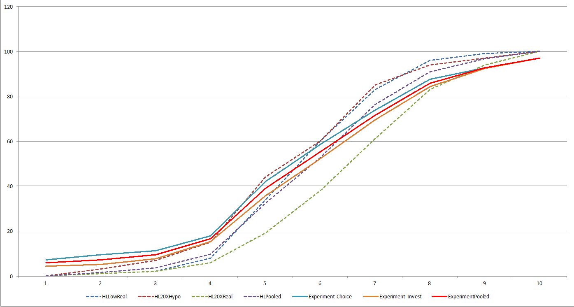

**Fig. 1A** Subjects' Holt-Laury Switch Bins (Solid Lines; Gains Only & Lose-Money Condition) versus Original Holt-Laury (2002) Switch Distribution (Dotted Lines)

Consider Figure 1, which illustrates the cumulative frequency of switch-point bins, both for the four original Holt-Laury (2002) conditions (dashed lines) and our various experimental baseline subjects (solid lines). As can be seen from the figure, our subjects appear to manifest a somewhat greater degree of risk aversion at the upper end of the HL scale than most of the HL conditions (other than the 20x real stakes condition). That said, our subjects appear to behave consistently in a manner that sits comfortably within the range of responses in Holt & Laury (2002). Moreover, note that our treatment and control subjects manifest nearly identical switch point distributions – a fact that we will utilize in our identification strategy below.Overall, we consider this to be reasonable grounds to believe that our data are highly comparable to Holt & Laury (2002), albeit possibly skewed slightly (but insignificantly) towards greater risk aversion.[21] This comparison provides some comfort that our data are comparable to both prior literature, as well as one another regardless of whether subjects they were assigned to the control or treatment group.

1. *Estimation Results*

Having largely satisfied ourselves of the compatibility of our experimental data with prior literature, we now proceed to estimate the effect of the manipulation variable “language” (representing the use of an Invest in Invention frame) on whether the subject takes a “safe” choice in an experimental setting.

Let $y_{i}∈\{0,1\}$ denote whether the subject takes the {risky, safe} decision. (Note that we normalize the “safe” decision as $y_{i}=1$, so that this fits into the standard framework for limited dependent variables). We use the standard limited dependent variable approach to estimate coefficients underlying the binary choice between projects. Assume that there is some “latent” risk aversion variable ${\hat{y}}_{i}$ for each experimental subject, which cannot be observed directly. For subject *i* the latent variable is defined by:

$${\hat{y}}_{i}=α_{0}+λw_{i}+βX_{i}+δz_{i}+ε_{i}$$

The subject’s action in is dictated by this latent variable, such that:

$$y_{i}=\left\{\begin{matrix}1 if {\hat{y}}_{i}≥0 \\ else\end{matrix}\right.$$

In the above setup, $α_{0}$ is an estimated constant, representing baseline risk aversion; $β$ is a vector of control-variable coefficients on demographic variables $X_{i},$ and $δ$ is a vector of “fixed effect” coefficients for (K-1) of the HL “bins” subjects fall into. Our coefficient of interest in this expression will be $λ,$ which embodies the marginal effect of being placed in the innovation “language” treatment group, (where $w_{i}=1$), as opposed to the pure risk frame (where $w_{i}=0$). The $ε_{i}$ denotes an error term on the latent variable. Because we predict that the Invest in Invention frame will make subjects *less* risk averse and *more* risk preferring, we will test a null hypothesis that $λ=0$ against the one-sided alternative that .[22]

Given the framework from above, the risky choice will be taken whenever

$$ε_{i}≤-\left(α_{0}+βX_{i}+δz_{i}+λw_{i}\right)$$

which occurs with probability:

$$Φ\left(\frac{-\left(α_{0}+βX_{i}+δz_{i}+λw_{i}\right)}{σ}\right)$$

And the safe choice will be taken whenever

$$ε_{i}>-\left(α_{0}+βX_{i}+δz_{i}+λw_{i}\right)$$

which occurs with probability:

$$1-Φ\left(\frac{-\left(α_{0}+βX_{i}+δz_{i}+λw_{i}\right)}{σ}\right)$$

Suppose that out of our N subjects, we observe *n<N* of them choose the safe 0063hoice ($y_{i}=1$) and the remaining *N-n* choose the risky choice ($y_{i}=0$). The appropriate likelihood function is defined as follows:

$$Λ\left(α_{0},β,δ,λ\right)=\prod_{i=1}^{N}{{\left[Φ\left(\frac{-\left(α_{0}+βX_{i}+δz_{i}+λw_{i}\right)}{σ}\right)\right]}^{1-y_{i}}}{\left[1-Φ\left(\frac{-\left(α_{0}+βX_{i}+δz_{i}+λw_{i}\right)}{σ}\right)\right]}^{y_{i}}$$

The log likelihood function is:

$$\ln\left(Λ\left(α_{0},β,δ,λ\right)\right)=$$

$$\sum_{i=1}^{N}{\left(1-y_{i}\right)∙ln\left(Φ\left(\frac{-\left(α_{0}+βX_{i}+δz_{i}+λw_{i}\right)}{σ}\right)\right)}+y_{i}∙ln\left(1-Φ\left(\frac{-\left(α_{0}+βX_{i}+δz_{i}+λw_{i}\right)}{σ}\right)\right)$$

The maximum likelihood approach chooses $α_{0},β,δ,λ$-- as well as $σ$-- to maximize the above function. As before, given our normality assumptions on $ε_{i}$, a Probit specification is appropriate.

As noted above, if the Invest in Invention frame has no effect, then one would predict $λ=0.$ If, in contrast, treatment makes subjects *less* risk averse and *more* risk preferring on the margin, then we would predict $λ<0$, we will test the null hypothesis that $λ=0$ against the one-sided alternative that $λ<0$.

Appendix B -- *Estimation Robustness on Keep v Invest in Invention*

The following tables report on alternative probit and logit estimations of Tables 2 and 3 in the text, which used OLS linear probability models.

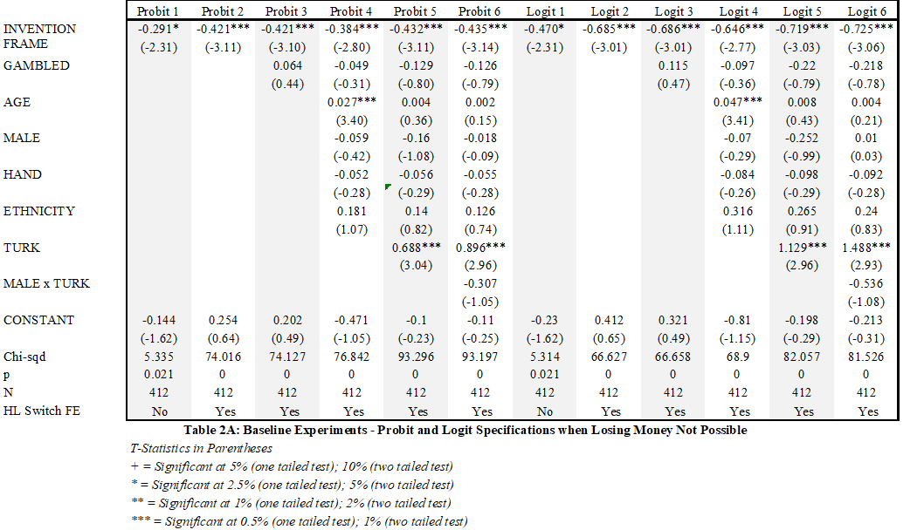

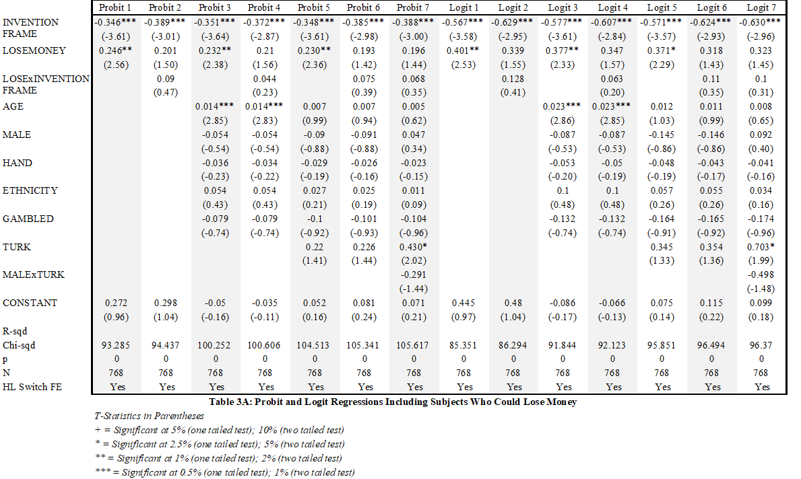

**Appendix C – “Keep v. Invest”**

|  |  |  |  |  |  |  |  |  |  |  |
| --- | --- | --- | --- | --- | --- | --- | --- | --- | --- | --- |
|  | Logit 1 | Logit 2 | Logit 3 | Logit 4 | Logit 5 | OLS 1 | OLS 2 | OLS 3 | OLS 4 | OLS 5 |
| INVENTION FRAME | -0.064 | -0.037 | -0.027 | -0.092 | -0.092 | -0.015 | -0.008 | -0.005 | -0.019 | -0.019 |
|  | (-0.21) | (-0.12) | (-0.08) | (-0.29) | (-0.29) | (-0.21) | (-0.11) | (-0.07) | (-0.26) | (-0.26) |
| GAMBLED |  |  | 0.346 | 0.273 | 0.273 |  |  | 0.077 | 0.062 | 0.062 |
|  |  |  | (0.92) | (0.73) | (0.73) |  |  | (0.89) | (0.73) | (0.73) |
| AGE |  |  |  | 0.026 | 0.026 |  |  |  | 0.005 | 0.005 |
|  |  |  |  | (1.47) | (1.47) |  |  |  | (1.48) | (1.48) |
| MALE |  |  |  | -0.113 | -0.113 |  |  |  | -0.023 | -0.023 |
|  |  |  |  | (-0.35) | (-0.35) |  |  |  | (-0.31) | (-0.31) |
| HAND |  |  |  | 0.505 | 0.505 |  |  |  | 0.1 | 0.1 |
|  |  |  |  | (0.85) | (0.85) |  |  |  | (0.86) | (0.86) |
| ETHNICITY |  |  |  | -0.556 | -0.556 |  |  |  | -0.137 | -0.137 |
|  |  |  |  | (-1.27) | (-1.27) |  |  |  | (-1.31) | (-1.31) |
| CONSTANT | 0.452* | 0.309 | 0.007 | -0.621 | -0.621 | 0.611*** | 0.576*** | 0.508** | 0.405 | 0.405 |
|  | (2.08) | (0.39) | (0.01) | (-0.56) | (-0.56) | (11.83) | (2.93) | (2.44) | (1.60) | (1.60) |
| r2 |  |  |  |  |  | 0.0002 | 0.059 | 0.064 | 0.097 | 0.097 |
| chi2 | 0.045 | 9.771 | 9.596 | 17.258 | 17.258 |  |  |  |  |  |
| p | 0.832 | 0.461 | 0.567 | 0.304 | 0.304 | 0.832 | 0.149 | 0.222 | 0.045 | 0.045 |
| N | 184 | 184 | 184 | 184 | 184 | 184 | 184 | 184 | 184 | 184 |
| HL Switch FE | No | Yes | Yes | Yes | Yes | No | Yes | Yes | Yes | Yes |

|  |  |  |  |
| --- | --- | --- | --- |
| *T-Statistics in Parentheses* |  |  |  |
| *+ = Significant at 5% (one tailed test); 10% (two tailed test)* | | | |
| *\* = Significant at 2.5% (one tailed test); 5% (two tailed test)* | | | |
| *\*\* = Significant at 1% (one tailed test); 2% (two tailed test)* | | | |
| *\*\*\* = Significant at 0.5% (one tailed test); 1% (two tailed test)* | | | |

**Appendix D – Keep v. Earnings Will Be**

|  |  |  |  |  |  |  |  |
| --- | --- | --- | --- | --- | --- | --- | --- |
|  | OLS 1 | OLS 2 | OLS 3 | OLS 4 | OLS 5 | OLS 6 |  |
| INVEST FRAME | 0.168*** | 0.082 | 0.072 | -0.008 | -0.057 | -0.061 |  |
|  | (2.70) | (1.26) | (1.10) | (-0.12) | (-0.82) | (-0.87) |  |
| AGE |  |  | 0.086 | 0.058 | 0.033 | 0.026 |  |
|  |  |  | (1.36) | (0.87) | (0.49) | (0.38) |  |
| MALE |  |  |  | 0.009*** | 0.005 | 0.004 |  |
|  |  |  |  | (3.24) | (1.58) | (1.28) |  |
| HAND |  |  |  | -0.119* | -0.138** | -0.012 |  |
|  |  |  |  | (-2.09) | (-2.45) | (-0.13) |  |
| ETHNICITY |  |  |  | -0.077 | -0.075 | -0.063 |  |
|  |  |  |  | (-1.00) | (-0.97) | (-0.81) |  |
| GAMBLED |  |  |  | 0.046 | 0.025 | 0.008 |  |
|  |  |  |  | (0.60) | (0.32) | (0.10) |  |
| TURK |  |  |  |  | 0.198* | 0.324*** |  |
|  |  |  |  |  | (2.13) | (2.83) |  |
| MALExTURK |  |  |  |  |  | -0.203+ |  |
|  |  |  |  |  |  | (-1.75) |  |
| CONSTANT | 0.443*** | 0.679*** | 0.622*** | 0.493** | 0.494*** | 0.464** |  |
|  | (12.59) | (3.81) | (3.42) | (2.43) | (2.62) | (2.54) |  |
| R-sqd | 0.024 | 0.116 | 0.122 | 0.173 | 0.187 | 0.196 |  |
| p | 0.007 | 0 | 0 | 0 | 0 | 0 |  |
| N | 291 | 291 | 291 | 291 | 291 | 291 |  |
| HL Switch FE | No | Yes | Yes | Yes | Yes | Yes |  |
|  | | | | | | | | | | | | |  |
|  | *T-Statistics in Parentheses* | | |  |  |  |  |  |  |  |  |  |  |
|  | *+ = Significant at 5% (one tailed test); 10% (two tailed test)* | | | | | | |  |  |  |  |  |  |
|  | *\* = Significant at 2.5% (one tailed test); 5% (two tailed test)* | | | | | | |  |  |  |  |  |  |
|  | *\*\* = Significant at 1% (one tailed test); 2% (two tailed test)* | | | | | | |  |  |  |  |  |  |
|  | *\*\*\* = Significant at 0.5% (one tailed test); 1% (two tailed test)* | | | | | | |  |  |  |  |  |  |

**Appendix E – Keep v Earnings Will Be**

|  |  |  |  |  |  |  |
| --- | --- | --- | --- | --- | --- | --- |
|  | Probit 4 | Probit 5 | Probit 6 | Logit 4 | Logit 5 | Logit 6 |
| INVEST FRAME | -0.046 | -0.183 | -0.202 | -0.073 | -0.28 | -0.308 |
|  | (-0.24) | (-0.93) | (-1.01) | (-0.23) | (-0.86) | (-0.92) |
| AGE | 0.163 | 0.102 | 0.087 | 0.261 | 0.165 | 0.136 |
|  | (0.86) | (0.52) | (0.45) | (0.82) | (0.50) | (0.41) |
| MALE | 0.028*** | 0.015 | 0.012 | 0.046*** | 0.026 | 0.022 |
|  | (3.01) | (1.45) | (1.16) | (2.88) | (1.42) | (1.14) |
| HAND | -0.343* | -0.403** | -0.035 | -0.575* | -0.674** | -0.062 |
|  | (-2.08) | (-2.40) | (-0.13) | (-2.08) | (-2.38) | (-0.14) |
| ETHNICITY | -0.213 | -0.222 | -0.187 | -0.347 | -0.359 | -0.308 |
|  | (-0.92) | (-0.94) | (-0.79) | (-0.91) | (-0.92) | (-0.78) |
| GAMBLED | 0.125 | 0.072 | 0.018 | 0.219 | 0.131 | 0.05 |
|  | (0.59) | (0.34) | (0.08) | (0.62) | (0.35) | (0.14) |
| TURK |  | 0.528* | 0.907*** |  | 0.845+ | 1.448** |
|  |  | (1.98) | (2.69) |  | (1.88) | (2.56) |
| MALExTURK |  |  | -0.602+ |  |  | -0.987+ |
|  |  |  | (-1.76) |  |  | (-1.70) |
| CONSTANT | -0.056 | 0.007 | -0.049 | -0.124 | -0.031 | -0.128 |
|  | (-0.09) | (0.01) | (-0.09) | (-0.12) | (-0.03) | (-0.14) |
| Chi-sqd | 46.117 | 53.59 | 57.758 | 41.356 | 47.639 | 51.466 |
| p | 0 | 0 | 0 | 0 | 0 | 0 |
| N | 291 | 291 | 291 | 291 | 291 | 291 |
| HL Switch FE | Yes | Yes | Yes | Yes | Yes | Yes |
|  | | | | | | |

1. **Acknowledgments** Many thanks to Stefan Bechtold, Christopher Buccafusco, Paul Edelman, Kirti Gupta, Damon Mateo, Roger Noll, Morgan Ricks, J. Jobu Babin, Andres Sawicki, Alexander Stremitzer, Seth Werfel, seminar participants at PatCon 7 at Northwestern University Pritzker School of Law, Vanderbilt Law, 2017 Economic Science Association World Meeting, the 4th Annual Roundtable on Empirical Methods in Intellectual Property, the 2017 Conference on Empirical Legal Studies, the January 2018 IP2 Conference on *Patent Practices and Policy: The Backbone of the Innovation Economy* at the Hoover Institution, and the 2017 IP Scholars Conference for helpful comments and discussions, and to Hoffmann Kim and Taylor Weidman for excellent research assistance. All errors are ours.

   ___________________________

   Elizabeth Hoffman

   Department of Economics, Iowa State University, 518 Farm House Lane, Ames, IA 50011

   E-mail: bhoffman@iastate.edu

   Phone: 515-294-0039

   David Schwartz • Matthew Spitzer

   Northwestern University Pritzker School of Law, 375 E. Chicago Ave., Chicago, IL 60611

   E-mail: {David.schwartz, Matthew.spitzer}@law.northwestern.edu

   Phone: 312-503-{2646, 8434}

   Eric Talley

   Columbia Law School, 435 West 116th Street, New York, NY 10027

   E-mail: etalley@law.columbia.edu

   Phone: 212-854-0437
2. These legal rules can be quite idiosyncratic. For a superb experimental test of the fairness of the German “Bestseller Paragraph” provision in copyright, and its effect on the market, see Engel and Kurschilgen 2011.
3. Bargh, John A., and Tanya L. Chartrand (2000), provides a guide to various priming methods used across psychological fields. van Schie and van der Pligt (1990) discuss the relevance of *salience*, which may be produced by priming.
4. Similarly, Ellingsen (2011) found that situational labels significantly affect behavior, they framed a Prisoner’s dilemma as “community game” or a “stock market game” they found that subjects were more cooperative when framed as a “community game.” Further, Tyran (2006) found that expectations of cooperation amongst others lead to an increase in cooperation with non-deterrent sanction laws.
5. For a highly imaginative connection of priming and memory, see Kusev, van Schaik and Aldrovandi (2012).
6. The study conducted in Schubert, et al. found that “female subjects do not generally make less risky financial choices” than men. However, the female subjects were more risk averse in abstract gambling situations (pg 384). Additionally, Lotz (2015) found “considerable gender differences between women and men that depended on the context of the game.” When the game demanded more giving, women displayed more generosity, while the “men’s behavior was non context-dependent.” Croson et al. (2009) observed differences in risk, social and competitive preferences; they noted that emotions, overconfidence and framing could be the cause behind sex differences. Additionally, Charness and Gneezy (2012) directly found that women are “less likely to invest.” When Eckel and Grossman (2008) conducted research in gambling games with three framings, they found that women were more risk averse even with an investment frame with no losses. In contrast, Nelson (2015) reviewed 35 empirical works that studied sex-based risk aversion, she determined that in many cases the difference between men and women lacked statistical significance.

  
7. Emotions like fear can alter risk decisions; Lee and Andrade (2015) studied the effect fear plays on risk taking. They induced fear by watching two horror movie clips, and observed that fear-induced subjects were more risk averse when the risk was framed as a stock market game. However, they found that risk taking *increased* when framed as an “exciting casino game.”
8. Kim and Hoffman (2018) examine the effect that prior good or bad news have on portfolio choices.
9. We could have used the simpler Eckel and Grossman (2008) risk aversion test. However, as Eckel and Grossman (2008) said themselves of Holt and Laury (2002), “This mechanism imposes a finer grid on the subjects’ decisions, and thus produces a more refined estimate of the relevant utility function parameters. However, this comes at a cost of increased complexity, which may lead to errors.“ (p. 2). Charness, et al. (2013) adds “The prevalent use of the Holt–Laury measure has allowed researchers to compare risk attitudes across a wide array of contexts and environments. In turn, this has facilitated a less fragmented approach to the study of risk preferences that minimizes methodological differences and aims to characterize a more general phenomenon. (p. 46) Since we wanted to estimate a risk aversion parameter, we made the decision to use Holt and Laury (2002), despite the increased complexity.
10. We needed to use the word “hypothetical” to avoid possibly misleading some subjects into believing that there was a real invention involved in the experiment. There was not.
11. See Appendix B.
12. |  |  |  |  |
    | --- | --- | --- | --- |
    | *T-Statistics in Parentheses* |  |  |  |
    | *+ = Significant at 5% (one tailed test); 10% (two tailed test)* | | | |
    | *\* = Significant at 2.5% (one tailed test); 5% (two tailed test)* | | | |
    | *\*\* = Significant at 1% (one tailed test); 2% (two tailed test)* | | | |
    | *\*\*\* = Significant at 0.5% (one tailed test); 1% (two tailed test)* | | | |

   
13. Note that some economists and legal scholars doubt the robustness of the empirical evidence supporting the endowment effect (Klass and Zeiler, 2013). Other researchers believe that subjects can debias to overcome any endowment effect (Arlen and Tontrup, 2015). For the purpose of this discussion, we will assume that the endowment effect – the tendency of people to value what they own more highly *because* they own the assets – is real.
14. See regressions results in Appendices C and D . [Make sure appendices C and D]
15. The expected value of the gamble *could* stay positive because of prizes, but those are sensitive to expectations about the extent to which cronyism, among other things, will twist the award of the prizes. We must await further experiments before we can say, with confidence, anything about these policy instruments.
16. We recognize that patents provide the right to exclude competitive for only a limited time period, and the limited duration may affect the value assigned to them by people in the world. We neither told subjects about the duration nor did duration affect the payouts in our experiment.
17. More precisely 189 out of 486 subjects took the certain choice in our experiments, combining the loss and no-loss versions. Considering only the no-loss experiments, 35.8% (111 out of 310 subjects) took the certain choice.
18. I.e., *V* = $8; *VH* = $30; *VL* = $3; and *q* = 1/3.
19. The HL elicitation subdivides the risk aversion domain A into K=10 ordered “bins” coinciding with:

    {
20. Our results change little if the “never switch” subjects are dropped entirely from our data set.
21. Beyond eyeballing, we checked whether our subjects appeared comparable to the simulated H-L data based on switching bins in an ordered probit/logit specification. When we compare the pooled HL data to our control group, we found a modest bias in the direction of risk aversion among our experimental controls. However, this bias is not statistically significant under conventional measures (z=1.55 & 1.63, respectively).
22. One caveat deserves mention here: Because our other control variables ( $X_{i}$ and $z_{i}$) are both elicited *after* the experimental manipulation, it is conceivable that the experimental manipulation itself affected post-manipulation responses. This fear is less salient with the demographic variables $X_{i},$ such as age, left-handedness, etc. However, the HL risk aversion elicitation, $z_{i},$ might well be altered by being assigned to the treatment or control group. Were this to happen, it would likely attenuate any results we find, which is good news for us. That said, this possible treatment effect on a RHS variable is worth keeping in mind in interpreting the regressions below; we will thus consider specifications that both exclude and include fixed effects for HL bins reported by the subjects. (We note, however, that the HL elicitations from our experimental control and treatment subjects appear virtually identical, giving us some confidence that the HL bins are not infected by our experimental manipulation – see Figure 1 above.)