**Winners and Losers after 25 Years of Transition: Decreasing Inequality in Slovenia**

Suzana Laporšek1

Peter F. Orazem2, 3

Milan Vodopivec1, 3

Matija Vodopivec1

1 University of Primorska, Slovenia

2 Iowa State University, USA

3 IZA Institute for the Study of Labor, Germany

**Abstract**

Wage inequality has fallen in Slovenia over the past 25 years, even as it has risen in most developed economies. Rates of return to education and work experience rose and remained high on average. However, rapid increases in the number of tertiary graduates have outpaced rising relative demand for skill for the youngest labor market entrants. As a result, the youngest cohorts of tertiary graduates have experienced declining returns to schooling and a downward shift in their occupational distribution, changes not experienced by older college graduates. These changes coincide with the installation of the Bologna reform that lowered the length of time necessary to complete a bachelor’s degree and contributed to the incentives to attend university. Falling returns to tertiary education contributed to declining within-cohort wage inequality for the young that were sufficiently large to lower overall wage inequality.

**Keywords:** inequality, returns to education, Bologna reform, Slovenia

**JEL codes:** I24, J31, P24

# Introduction

Most developed countries have experienced rising income inequality since the 1980s (Cingano, 2014). While inequality has fallen across countries in Europe (Brandolini and Rosolia, 2019), inequality has risen within countries, both in the EU-15 and, since 1993, in most of the new EU (transition) countries (Mitra and Yemtsov, 2006; Brandolini and Rosolia, 2019). All of these countries experienced the common technological growth that increased demand for skilled workers relative to less skilled workers (Katz and Murphy, 1992; Mitra and Yemtsov, 2006). The complementarity between capital and skill led to progressive increases in the wages of tertiary graduates relative to high school educated workers. Rising returns to skill explain two-thirds of the increase in inequality in the U.S. (Goldin and Katz, 2007) and one-third in the OECD (Dabla-Norris, 2015).

In the transition economies, however, two factors should have further increased the tendency toward wage inequality.[1] The first is that by disabling the previous system that transferred income from the most to the least productive, inequality should rise.[2] Moreover, the decline of state-owned enterprises resulted in shifting labor demand toward consumer and service sectors that were suppressed under the planned systems. Shifting labor demand tended to favour the most educated and they favoured women because the subsidies to heavy industry and state-owned firms were discontinued, and these sectors atypically employed the least educated and men.

A second source of rising inequality is the fact that transition increased the demand for managerial skills. Schultz (1975) posited that human capital was most valuable during periods of disequilibria. This implies that the returns to skill would be low in economies lacking technical change and with limited exposure to markets, including centrally planned systems, while in market systems with constant exposure to input, output, technology and price shocks, human capital is in greatest demand. Indeed, as shown by Orazem and Vodopivec (1995), Fleisher *et al* (2005) and Mitra and Yemtsov (2006), relative returns to schooling rose rapidly and approached the returns found in market systems.[3]

Slovenia should have experienced rising inequality as it experienced the progressive exposure to skill-biased technical change; the transition to a market system that tied pay more closely to productivity; and the rising demand for managerial skills. Yet after the recovery from the 1991 recession, inequality fell (Figure 1), reaching one of the lowest levels in the EU-28. Slovenia is not unique in its falling inequality. In 4 out of 11 other European transition countries with available data, inequality has fallen since the early transition (Figure 2).

**Figure 1: Gini coefficient in Slovenia based on wages, 1992–2015**

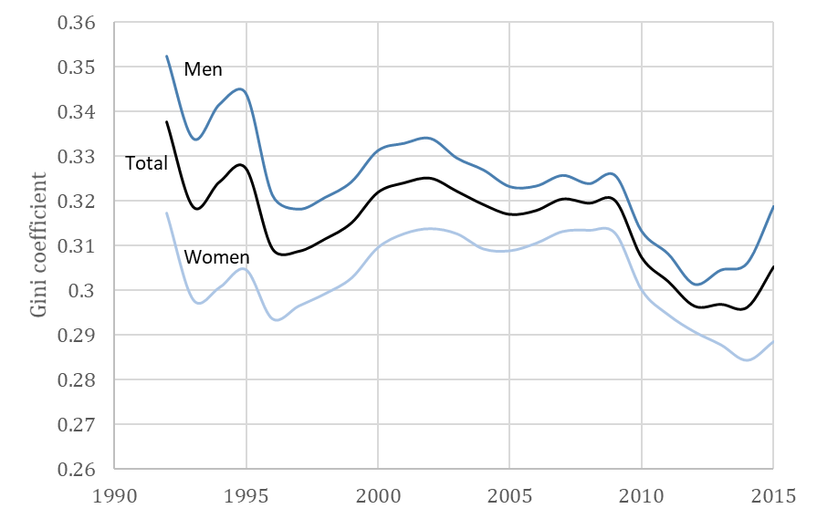

*Source:* Authors’ computation based on the universe of all workers in the Slovenia labor market aged 25-60, 1992–2015.

**Figure 2: Gini coefficients based on income in selected transition economies, early 1990s and 2015**



*Source:* Authors’ compilation of World Bank (2019b) World Development Indicators.

If inequality is falling, have returns to education and work experience that rose immediately upon the initiation of the transition to market economy begun to fall? Have the demands for managerial skills diminished as the transition had progressed? Has Slovenia not experienced the steady progress of skill-biased technical change? Or is there a different reason for why Slovenia has bucked the trend of rising income inequality over the past 25 years? If so, do the lessons from Slovenia apply to other countries in the EU?

We begin our analysis by examining and rejecting several factors that could conceivably explain the decrease in wage inequality in Slovenia. In fact, inequality fell in Slovenia *despite* a fast pace of technological change, an increase in returns to education in the 1990s, and a rapidly increasing return to experience. Instead, driving the falling inequality is a rapid expansion of the number of young tertiary education students that, unlike in most of the industrialized economies, rose faster than the rising relative demand for skill. At about the same time, the adoption of the Bologna academic reforms lowered the length of study necessary for a bachelor’s degree and apparently lowered the average quality of tertiary graduates. The youngest cohorts of tertiary graduates began to enter occupations that previously were primarily filled by secondary graduates. As a result, successive birth cohorts of young Slovenians experienced steadily declining returns to schooling and falling within-cohort wage inequality starting in 2000. These initial declines in returns to schooling persist and are sufficiently large to swamp the effect of factors that would normally increase inequality. As other countries are also experiencing rising entry into tertiary education and potentially declining graduate quality due to the adoption of the Bologna reforms, the Slovenia case may presage what other European countries will be experiencing over the next few decades.

# Data and Methods

The data used in this paper were created by linking several administrative databases covering the entire Slovenian workforce for the 1991–2015 period. For every worker, the database contains detailed information on employment, unemployment and wages. Each individual’s records are linked via their unique personal identification number. The following administrative data sources are used:

1. *Data on worker earnings*. Provided by the Pension and Disability Insurance Institute of Slovenia. Comprised of earnings information for every employment spell for every individual with earnings.
2. *Data on worker history*. Compiled by the Statistical Office of Slovenia. Includes beginning and ending dates for every employment spell, employer identification code, occupation, appointment type, and personal characteristics (age, education, and gender).

This allows us to monitor the entire workforce over that time period, both by comparing different cohorts at one point in time, and by following cohorts of workers longitudinally over time. In order to account for selection into employment, which we do in all the wage regressions to calculate returns to education and experience, we use the entire population aged 18–60 that appears in either the employment or unemployment records.[4] This allows us to generate unique insights into how Slovenia managed to lower inequality, with estimates of returns to education and experience that are comparable over time despite the changes in the structure of employment.

Much of the analysis is based on Mincerian earnings functions, estimated both cross-sectionally and longitudinally, of the following form:

Cross-Sectional: ${lnW}_{it}^{c}= \sum_{k=1}^{6}{β_{k}^{E}E_{itk}^{c}}+ \sum_{j=1}^{4}{{{β_{j}^{X}(X}_{it}^{c})}^{j}}+ Z_{it}^{c'}β^{Z}+ ε_{it}^{c}$ (1)

Longitudinal: ${lnW}_{it}^{c}=\sum_{k=1}^{6}{\sum_{c=1}^{C}{β_{kc}^{E}E_{itk}^{c}}}+ \sum_{j=1}^{2}{{{\sum_{c=1}^{C}{β_{jc}^{X}}(X}_{it}^{c})}^{j}}+ Z_{it}^{c'}β_{c}^{Z}+ ϵ_{it}^{c}$ (2)

where $E_{itk}^{c}$ is a series of 6 dummy variables indicating levels of schooling from incomplete primary to university; $X_{it}^{c}$ is years of potential work experience calculated based on educational attainment; and $Z_{it}^{c'}$ is a vector of time controls and other individual controls such as Slovene citizenship and type of employment contract. The cross-sectional estimates constrain the coefficients to be the same across all birth cohorts, while the longitudinal estimates allow the coefficients to differ by cohort. All estimates control for selection into the labor market using the Heckman selection correction procedure.

# Explaining Decreasing Earnings Inequality in Slovenia: Technological Change, Returns to Education and Experience

In this section, we evaluate whether the decrease in earnings inequality in Slovenia can be explained by a slower pace of skill-biased technological change, a decrease in rewards to experience, or decreasing returns to education. We will conclude that only the last explanation holds, but that the decrease in returns to schooling is confined to only the youngest birth cohorts. Nevertheless, the falling rewards to schooling for the young are sufficient to decrease both within cohort inequality and overall labor market inequality as well.

**3.1 It Is Not Slow Technological Change**

Figure 3 shows the time path of output per worker in Slovenia and other transition economies in Central and Eastern Europe in the 1987–2014 period. All of the transition economies have been increasing their labor productivity more rapidly than the other EU countries. The average growth rate of output per hour was 3.3% per year in the transition countries and 2.9% per year in Slovenia, but only 2.3% per year in the EU-15 market economies. Between 1990 and 2014, the productivity gap between Slovenia and the EU average fell from 79% to 53%. So, even though its average growth rate was slower than in some other transition economies, Slovenia was not lagging in technological growth over the period.

**Figure 3: Time path of real GDP per hour in transition economies and in the EU-15 countries, 1990–2014**

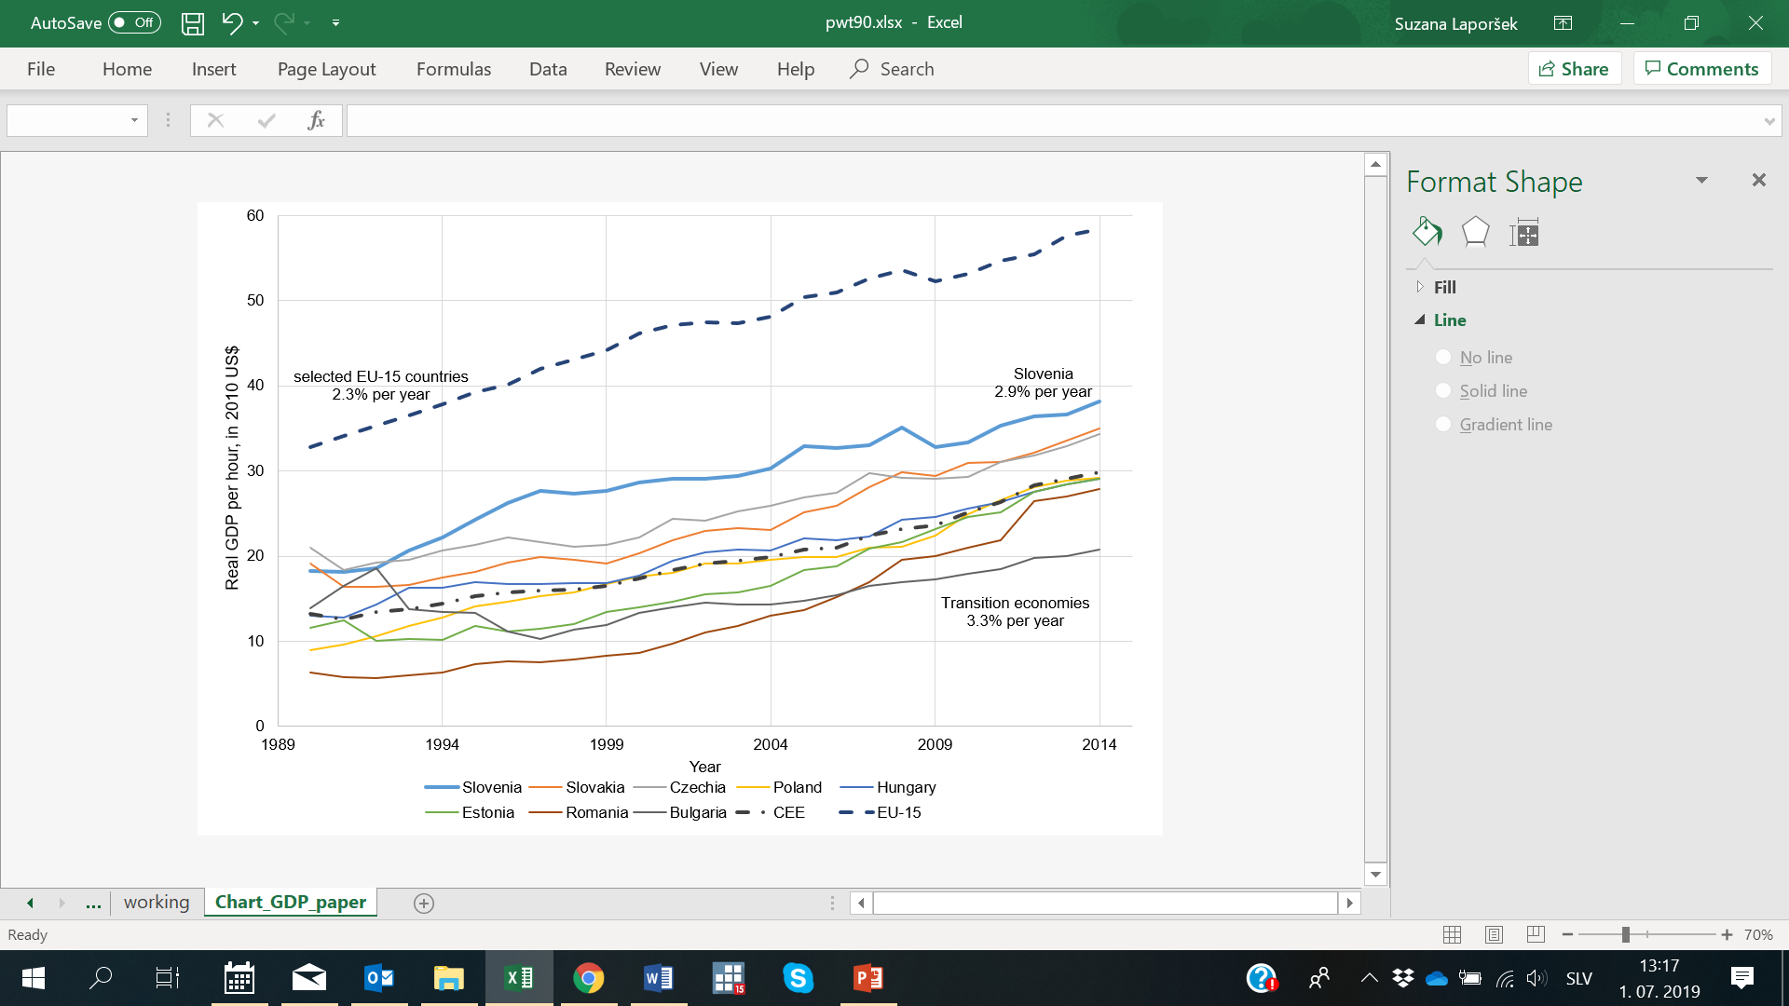

*Notes*: The data for the EU-15 countries include data for Austria, France, Germany, Italy, the Netherlands and the United Kingdom.

*Source:* Penn World Tables, 2019.

**3.2 It Is Not Falling Rewards to Experience**

There has been a steady rise in the cross-sectional synthetic life cycle earnings profile over time. Figures 4A-B trace out the pattern of earnings by years of experience for both men and women, using the coefficients from estimation of equation (1) for various years. The apparent reward from a year of work experience has not fallen for either men or women. The most rapid gains are from the depressed wages of 1991 to 1995, but the gains continue in every subsequent year as the benefits of rising labor productivity noted in Figure 3 were shared by workers.

However, the cross-sectional pattern masks an even faster increase in wages if we follow a cohort over time. That means that the cross-sectional wage pattern has consistently underpredicted the earnings of young Slovene workers as they age. To show this, we trace the implied longitudinal earnings path using Figure 4A as the base and illustrate the result in Figure 4C. It is clear that the longitudinal age-earnings profile is much steeper than is implied by the cross-sectional pattern. In effect, the returns to early work experience rose so rapidly that it flattened the cross-sectional returns, understating the returns to schooling. Figure 4D illustrates the life earnings profiles for various birth cohorts, using the cohort-specific rewards to experience implied by the coefficients from Equation (2). We use the male returns as potential experience will have less error as a measure of actual experience. The returns to work experience rose consistently over the transition and much more rapidly than would be implied by the cross-sectional estimates.

**Figure 4A: Cross-sectional male earnings by years of potential experience, 1991–2015**



*Note:* Regression results used to generate above figure are reported in detail in Table A1.

*Source:* Authors computation based on the universe of all workers in the Slovenia laborlabor market aged 25–60, various years, 1991–2015.

**Figure 4B: Cross-sectional female earnings by years of potential experience, 1991–2015**



*Note:* Regression results used to generate above figure are reported in detail in Table A2.

*Source:* Authors computation based on the universe of all workers in the Slovenia labor market aged 25–60, various years, 1991–2015.

**Figure 4C: Cross-sectional male earnings by years of potential experience, 1991–2015, with cohort returns superimposed**



*Note:* Regression results used to generate above figure are reported in detail in Table A1.

*Source:* Authors’ computation based on the universe of all workers in the Slovenia labor market aged 25–60, various years, 1991–2015.

**Figure 4D: Longitudinal male earning by years of potential experience, various birth cohorts**

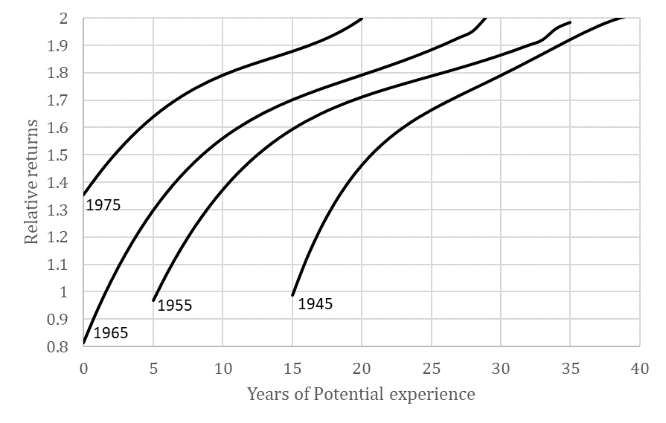

*Source:* Authors’ computation based on the universe of all workers in the Slovenia labor market born in 1945, 1955, 1965, and 1975 and observed employed in any of the years 1991–2015.

**3.3 Returns to Education, Cohort Inequality, and the Supply of Tertiary Graduates**

A clue to the source of declining wage inequality can be obtained by examining the returns to education. In Figures 5A-B, we trace out the time path of returns to schooling as estimated by the cross-sectional Mincer log earnings functions (1).[5] Orazem and Vodopivec (1995) had noted the sharp increase in returns to schooling in the early transition, and returns to tertiary education continued to rise through 2000. Returns are higher for women than men. The returns to tertiary graduates fell after 2000, although they remained high compared to the 10% per year norm in the OECD economies.

**Figure 5A: Estimated male relative returns to schooling by education group for various years, 1991–2015**

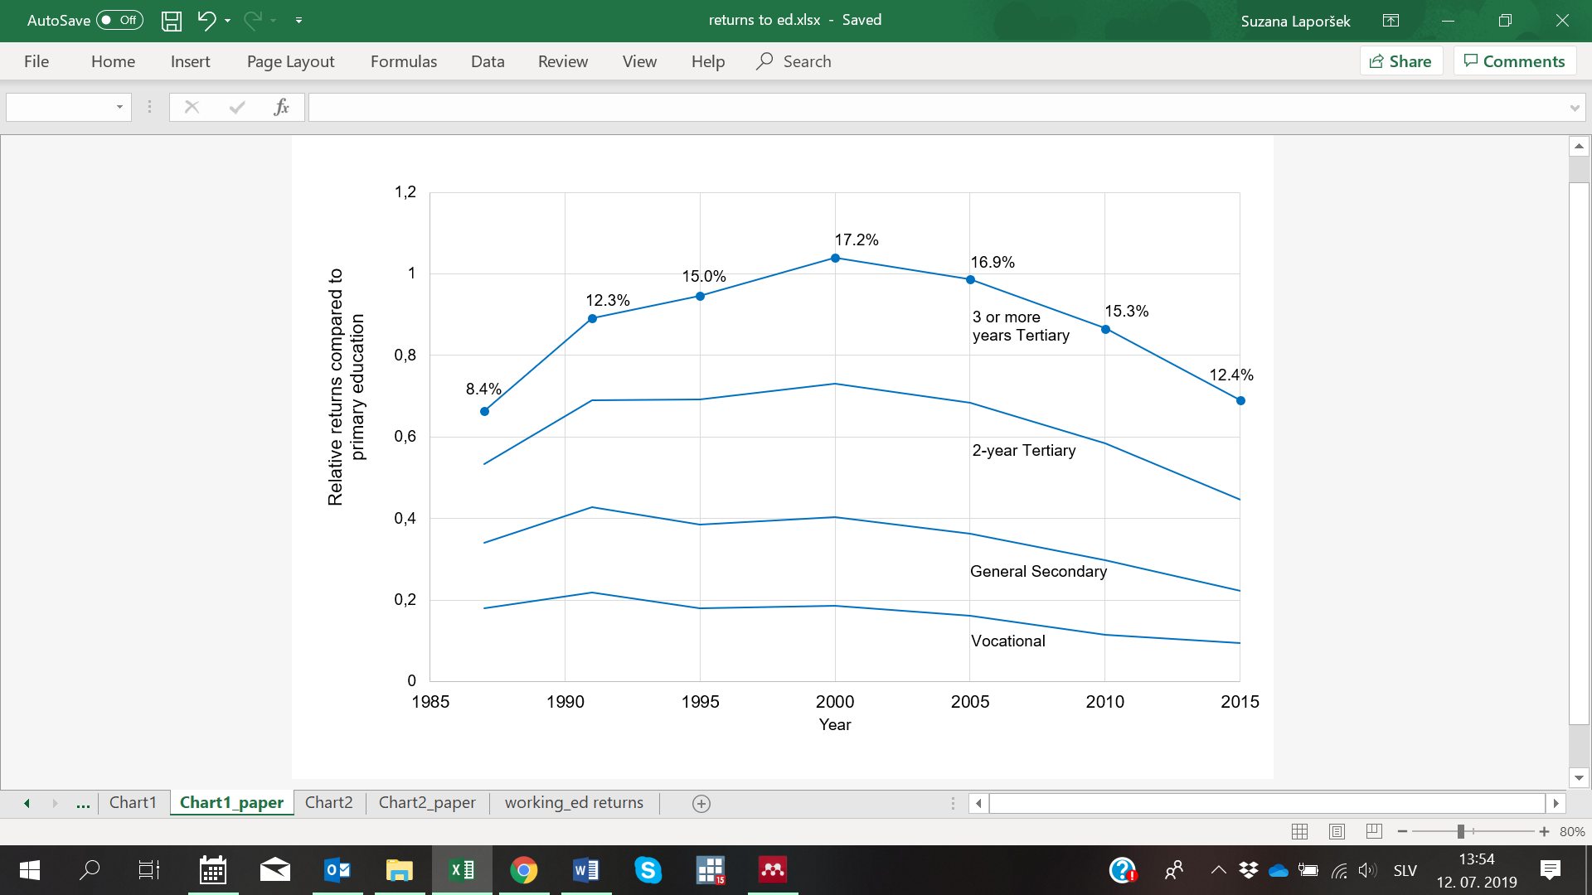

*Note:* Relative returns refer to a relative return per year of additional study. Regression results used to generate above figure are reported in detail in Table A1.

*Source:* Authors’ computation based on the universe of all workers in the Slovenia labor market aged 25–60, various years, 1991–2015. Estimates refer to the annualized returns to tertiary relative to primary education.

**Figure 5B: Estimated female relative returns to schooling by education group for various years, 1991–2015**

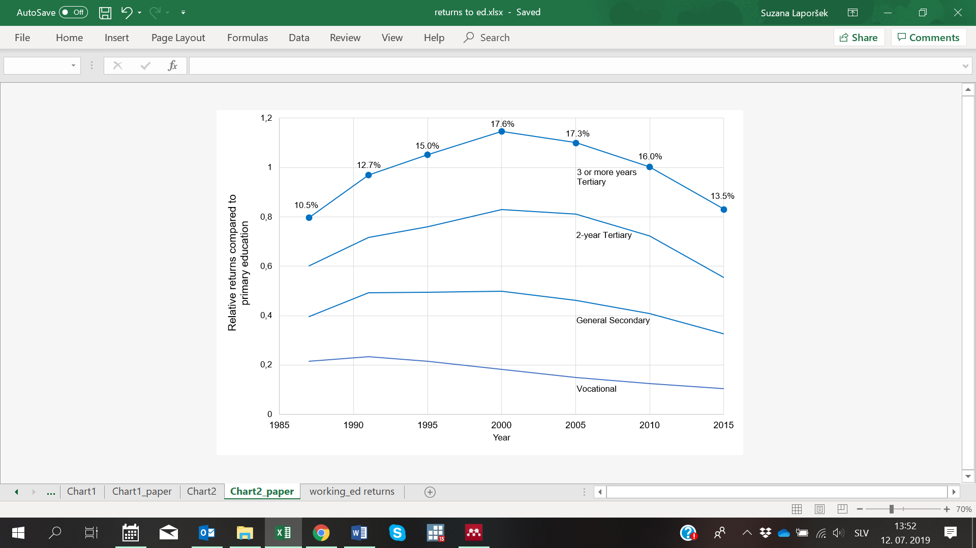

*Note:* Relative returns refer to a relative return per year of additional study. Regression results used to generate above figure are reported in detail in Table A2.

*Source:* Authors’ computation based on the universe of all workers in the Slovenia labor market aged 25–60, various years, 1991–2015. Estimates refer to the annualized returns to tertiary relative to primary education.

To delve further into the decline of returns to education after 2000, in Figure 6 we report the returns for secondary and tertiary education graduates by birth cohort as compiled from Mincer log earnings functions (2) reported in detail in Tables A3 and A4. A striking feature emerges: for successive births cohorts, the returns to education decline. The drop occurs for less educated workers as well. For the youngest cohorts, returns to schooling are one-third that for the oldest cohorts. Therefore, falling inequality is a result of differences in relative returns to education for older and younger members of the Slovenian workforce.

**Figure 6: Relative returns to schooling for male and female tertiary and secondary graduates in Slovenia for various birth cohorts, 2015**

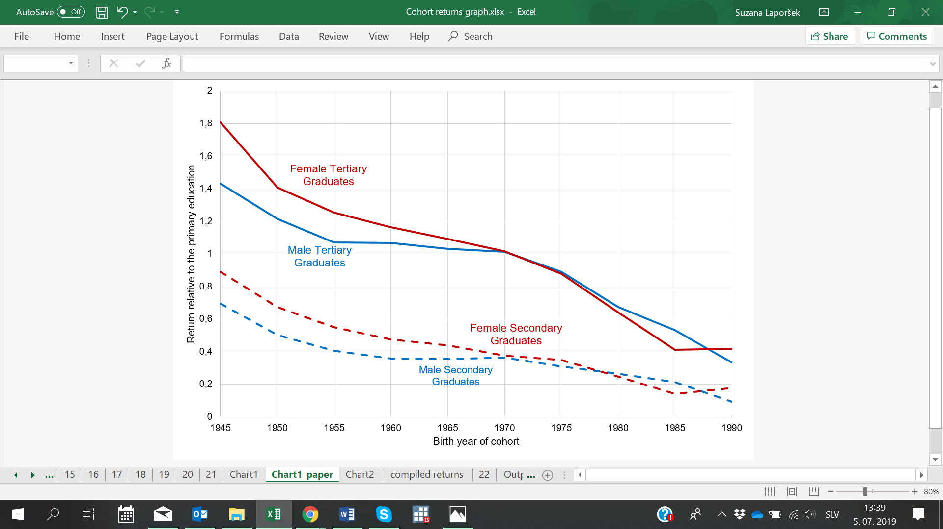

*Note:* Regression results used to generate above figure are reported in detail in Tables A3 and A4.

*Source*: Authors’ computation based on the universe of all workers in the Slovenia labor market born in 5-year intervals from 1945–1990.

This hypothesis is supported by birth cohort-specific Gini coefficients shown in Figure 7. Inequality increases as a cohort ages, as wages fan out reflecting differences in productivity growth between otherwise similarly educated and experienced individuals. However, the remarkable pattern in Figure 7 is the decrease in inequality for each successive birth cohort. Driving the decline in inequality in Slovenia is the increasingly egalitarian wage distribution for the youngest Slovenians. Progressive decreases in returns to schooling would be consistent with a pattern of decreasing within cohort inequality.

**Figure 7: Longitudinal Gini coefficients for various birth cohorts in Slovenia, 1992–2015**

*Note:* Gini coefficients are computed for each of the years 1991–2015

*Source*: Authors’ computation based on the universe of all workers in the Slovenia labor market born in 5-year intervals from 1945–1980.

One reason we might experience falling rewards to schooling and falling inequality concentrated among the youngest cohorts would be progressively increasing supplies of young tertiary graduates that rises faster than technological changes. If young and old tertiary graduates are not perfect substitutes, the depressing effect of an unusually large supply of young tertiary graduates on returns would be concentrated on the young. In Figure 8, we present the ratio of first-year tertiary entrants to the number of 19-year-olds in the population. The ratio can be greater than 1 if tertiary entrants are not only the most recent secondary school graduates but also older persons. Starting with independence in 1991, there was a rapid increase in the proportion of the population going to tertiary education. The share of employed 25–29-year-olds with tertiary degree rose from 8% in 1991 to 29% in 2015. Slovenia had the 7th fastest growth in tertiary graduates in Hanushek’s (2016) compilation.[6] It seems that the growth of supply may have overtaken the growth in demand for tertiary graduates.

**Figure 8: Ratio of first-year tertiary entrants to the population of 19-year-olds, 1952–2013**



*Source*: Statistical Office of the Republic of Slovenia, Statistical Yearbook of the Republic of Slovenia, various years.

# Explaining Decreasing Earnings Inequality in Slovenia: The Role of Occupations

**4.1 Quality of Jobs Taken by Younger Compared to Older Tertiary Graduates**

One possible indication that the supply of tertiary graduates has overtaken the local market demand is tertiary graduates starting to take jobs that were previously held by less-educated workers. To investigate this, we developed a ranking of occupations based on the average pay across all incumbents in each occupation over the 2000–2015 period. This gives us an index of occupational pay or, assuming that wages equal marginal revenue products, of occupational productivity. We can then generate occupational distributions for various groups of workers as ordered by occupational productivity indices to examine, for example, if there has been a deterioration in the quality of jobs taken by younger compared to older birth cohorts.

As shown in Figure 9A, there was no change in occupational productivity distributions over time for either experienced workers or for labor market entrants. However, there is a clear leftward shift in the occupational productivity distribution taken by new labor market entrants with tertiary degrees compared to experienced tertiary educated workers (Figure 9B). This happened even though there have been more entry-level jobs for tertiary educated graduates.

**Figure 9A: Occupational pay index distribution, all workers and all new labor market entrants, 2000–2015**

|  |  |
| --- | --- |
| Experienced workers | New labor market entrants |

*Note:* For each occupation, occupational pay index is defined as an average pay of all incumbents over the 2000–2015-year period.

*Source:* Authors’ computation based on the universe of all workers entering the Slovenia labor market in 2000 and still working in 2015.

**Figure 9B: Occupational pay index distribution, all tertiary educated workers and all new tertiary educated labor market entrants, 2000–2015**

|  |  |
| --- | --- |
| Experienced workers | New labor market entrants |

*Note:* For each occupation, occupational pay index is defined as an average pay of all incumbents over the 2000–2015-year period.

*Source:* Authors’ computation based on the universe of all workers entering the Slovenia labor market in 2000 and still working in 2015.

We can illustrate the changing occupational distribution for the tertiary educated market entrants in two ways. The first holds constant the occupational distribution of the tertiary educated labor market entrants in 2000 as the reference. We can then illustrate how the occupational distributions of subsequent cohorts of tertiary educated entrants compare to the 2000 distribution. For perspective, we also compare the overall occupational distributions across all new labor market entrants for the same years.

As shown in Table 1, Panel A, there was little apparent change in the occupational distribution over the 15 years from 2000 to 2015. The share of workers getting jobs in the bottom 25% of occupations fell, but the share of workers getting jobs at the upper tail stayed practically unchanged. The implication is that there has been some upskilling of occupations taken by market entrants from the lowest to the second quartile occupations in the occupational distribution.

Turning to the labor market entrants with tertiary degrees, it is interesting to note that they were more likely than other education groups to enter occupations at the bottom of the occupational distribution. In 2000, 18% of tertiary graduates took jobs in the bottom 10% of the distribution and 69% were in the lower half of the occupational distribution, compared to 56% overall. By 2015, the share of tertiary graduates with jobs at the upper half of the occupational distribution rises somewhat, from 31% to 36%, and so the upper tail of tertiary graduates appears to be taking somewhat better jobs than the 2000 graduating class. However, 29% of tertiary graduates took jobs in the bottom 10% of the occupational distribution even though the overall labor market entrant share of those jobs was declining! Clearly the market entry job opportunities for a substantial proportion of tertiary graduates deteriorated between 2000 and 2015 compared to the market for entrants overall.

It is possible that the falling market opportunities for newly minted tertiary graduates is due to declining demand for tertiary graduates rather than excess supply. To investigate that question, we reframe the reference to be the occupational distribution for all workers in each year rather than fixing the reference distribution in 2000 (Table 1, Panel B). For reference, we present the distribution across all experienced workers in the same years. By definition, the reference distribution should be 10%, 25%, 50%, 75% and 90%, but lumping of incumbents in occupations results in slight deviations from the expected distribution.[7] In 2000, tertiary graduates entered the jobs in the lower half of the occupational distribution at nearly the same rate as incumbents. Tertiary graduates were slightly more likely to be in the upper half of the distribution (49% versus 44%) but were more concentrated in the third quartile than the fourth quartile of the distribution. By 2015, we again see a massing of tertiary graduates in the bottom 10% of the occupational distribution. The rest of the distribution matches almost exactly the overall distribution of jobs, suggesting that the falling opportunities for tertiary graduates is for students who previously had taken jobs in the 11–25% range of the occupational pay distribution. Meanwhile, a larger share of tertiary graduates was taking jobs in the upper 25% of the occupational distribution. The observed pattern is consistent with a surplus of low-quality tertiary graduates crowding the bottom half of the occupational distribution while higher skilled tertiary graduates are doing no worse and perhaps slightly better than past cohorts in competing for positions in the most skilled jobs.

**Table 1: Changing occupational distribution for newly entering workers compared to past entrants and compared to current incumbent workers, 2000–2015**

|  |  |  |  |  |  |  |  |  |  |  |
| --- | --- | --- | --- | --- | --- | --- | --- | --- | --- | --- |
| Panel A: Occupational distribution for labor market entrants using the 2000 entrant occupational percentile cut points | | | | | | | | | | |
| Year | Group | Percentile | | | | | | | | |
| 10th | | 25th | | 50th | | 75th | | 90th |
| 2000 | All | 0.09 | | 0.32 | | 0.56 | | 0.75 | | 0.89 |
| **Tertiary** | **0.18** | | **0.25** | | **0.69** | | **0.85** | | **0.96** |
| 2005 | All | 0.07 | | 0.29 | | 0.50 | | 0.72 | | 0.88 |
| **Tertiary** | **0.15** | | **0.32** | | **0.57** | | **0.83** | | **0.95** |
| 2010 | All | 0.05 | | 0.23 | | 0.48 | | 0.68 | | 0.87 |
| **Tertiary** | **0.19** | | **0.33** | | **0.57** | | **0.83** | | **0.94** |
| 2015 | All | 0.06 | | 0.26 | | 0.56 | | 0.74 | | 0.90 |
| **Tertiary** | **0.29** | | **0.41** | | **0.64** | | **0.84** | | **0.95** |
|  |  |  |  | |  | |  | |  | |
| Panel B: Occupational distribution for labor market entrants using the contemporaneous overall occupational percentile cut points | | | | | | | | | | |
| Year | Group | Percentile | | | | | | | | |
| 10th | | 25th | | 50th | | 75th | | 90th |
| 2000 | All | 0.09 | | 0.32 | | 0.56 | | 0.75 | | 0.89 |
| **Tertiary** | **0.11** | | **0.25** | | **0.51** | | **0.83** | | **0.95** |
| 2005 | All | 0.08 | | 0.28 | | 0.50 | | 0.72 | | 0.88 |
| **Tertiary** | **0.14** | | **0.29** | | **0.54** | | **0.79** | | **0.93** |
| 2010 | All | 0.07 | | 0.29 | | 0.49 | | 0.72 | | 0.88 |
| **Tertiary** | **0.14** | | **0.31** | | **0.53** | | **0.79** | | **0.92** |
| 2015 | All | 0.09 | | 0.32 | | 0.56 | | 0.76 | | 0.91 |
| **Tertiary** | **0.19** | | **0.35** | | **0.56** | | **0.78** | | **0.91** |

*Source:* Authors’ computation based on the universe of all workers in the Slovenia labor market aged 25-60, 1991–2015.

**4****.2 The Bologna Reforms and the Quality of Tertiary Graduates**

The persistent life-cycle decline in returns to tertiary degree suggests a decrease in average quality of tertiary graduates, as one would expect the effects of a surge in the supply of graduates would dissipate over time as young and old graduates become more substitutable with experience gap declining. This decline coincides with the introduction of an EU-wide institutional change: the Bologna higher education reform. We investigate the link between this reform and the observed decline in returns.

In Slovenia pre-Bologna tertiary education, there was a 3-year practically oriented bachelor’s degree program, and a 4-year academically oriented bachelor’s degree program. Starting 2005/2006, new tertiary programs were introduced with the main changes being the reduction of the length of most bachelor’s degree programs from 4 to 3 years, and the revamping of the content of most master’s degree programs to become more practical. From 2006–2016, students could be enrolled in either the pre- or post-Bologna programs.[8]

In Figure 10A, we examine the occupational success of bachelor’s degree recipients under the Bologna reform compared to the graduates of the pre-Bologna 3- and 4-year bachelor’s programs. The occupational distribution for the pre-Bologna 4-year academically trained graduates was to the right of the pre-Bologna 3-year practically trained graduates. The post-Bologna 3-year academically trained graduates have occupational distributions that lie to the left of their pre-Bologna 4-year academically oriented bachelor’s degree counterparts. In addition, the post-Bologna 3-year practically trained graduates perform worse than their pre-Bologna counterparts. What’s more, the post-Bologna 3-year academically trained graduates look more like the pre-Bologna 3-year practically trained graduates, with only a small upper-tail taking jobs more typical of the pre-Bologna 4-year academically trained graduates.

**Figure 10A: Occupational pay index distribution of new labor market entrants aged 30 or less by completed bachelor’s degree program, 2015**

*Note:* For each occupation, occupational pay index is defined as an average pay of all incumbents over the 2000–2015-year period.

*Source:* Authors’ computation based on the universe of all workers entering the Slovenia labor market in 2000 and still working in 2015.

When we compare the new and old master’s degree recipients (Figure 10B), the post-Bologna 5-year master’s students have occupational distributions that overlap closely with the pre-Bologna 4-year academically oriented bachelor’s degree recipients. The pre-Bologna 6-year master’s degree recipients have occupational distributions to the right of the post-Bologna 5-year master’s degree recipients. The new 3-year academically oriented bachelor’s degree recipients clearly are not competing for the best jobs that formerly went to academically trained graduates. Figures 10A-B show that the Bologna reforms, together with the supply shock of tertiary graduates, contributed to the reduction of the reward to tertiary study for the youngest Slovenes.[9]

**Figure 10B: Occupational pay index distribution of new labor market entrants aged 30 or less, undergraduate academic and master study programs, 2015**

*Note:* For each occupation, occupational pay index is defined as an average pay of all incumbents over the 2000–2015-year period.

*Source:* Authors’ computation based on the universe of all workers entering the Slovenia labor market in 2000 and still working in 2015.

**4.3 First Jobs: Blemishes or Scars?**

The occupation at entry may change, and so there may be no permanent loss to the young cohorts of tertiary graduates who are entering low productivity occupations. We analyse whether initial occupation or contract type results in persistently low wages by examining longitudinal data on the 2000 labor market entrants, the earliest entry cohort for which we have occupational data. Figure 11 shows the relationship between each entrant’s 2000 occupational pay level on the horizontal axis and his or her 2015 occupational pay level, by educational attainment level at entry. The 45° line represents the expected relationship if initial occupation was perfectly correlated with later occupational pay level. For all education groups, the relationship is flatter than the 45° line (but with a positive intercept), indicating that entrants into the lower-paid occupations tend to move to higher-paid occupations over time. The likelihood of moving to higher-paid occupations appears to be strongest for the most educated.

**Figure 11: Relationship between 2000 and 2015 occupational status for the 2000 labor market entry cohort, by educational attainment level**

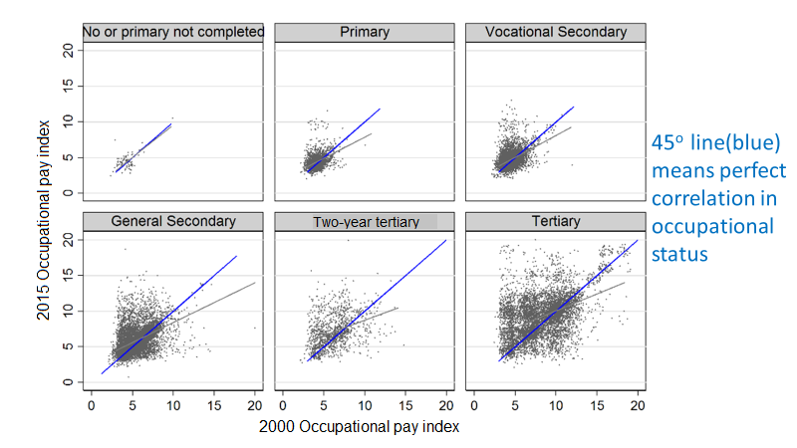

*Notes:* 45° line (blue) means perfect correlation in occupational status. For each occupation, occupational pay index is defined as an average pay of all incumbents over the 2000–2015-year period.

*Source:* Authors’ computation based on the universe of all workers entering the Slovenia labor market in 2000 and still working in 2015.

To examine the relationship between initial and subsequent jobs more formally, we regress wages at the end of our sample period, 2015, on several explanatory variables – on current and initial occupational pay level, education level, contract type, and ethnicity (being a Slovene or non-Slovene). We also include a measure of the minimum wage relative to the occupational wage as the period coincides with an aggressive increase in the minimum wages between 2009–2015 that would have increased wages for the least skilled occupations.

The results are reported in Table 2. Being in a higher-paid occupation raises wages for tertiary educated workers but not for other education groups. Holding current occupational pay fixed, starting in a higher-paid occupation in 2000 increased wages in 2015 for all education groups, significantly so for all but the primary educated. The pattern of signs suggests that tertiary graduates who enter high-paid occupations experience faster wage growth when they remain in higher-paid occupations, while less-educated entrants into those occupations experience slower wage growth.

Workers who begin on fixed-term contracts in 2000 have significantly lower wages 15 years later. If they are still on fixed-term contracts in 2015, their wages are substantially lower still. Combining the initial contract type (fixed-term versus permanent) with the initial occupational pay in 2000, it is apparent that the type of initial job taken in 2000 has a persistent effect on wages 15 years into the work careers of the 2000 entry cohort. These permanent effects may reflect unobserved abilities with the least able sorting into lower skilled occupations and fixed-term contracts. However, the estimates also hold constant the current occupational pay and contract type in 2015 which should already reflect the sorting effects of those unobserved abilities. While not conclusive, the results suggest that there are persistent scarring effects of starting work careers in bad jobs.

Turning to the education effects in column 1, it is apparent that the most educated experienced the fastest wage growth, holding occupation and contract type fixed. Graduates of tertiary education entering into lower-wage occupations experienced 21% faster wage growth within the lower-paid occupations than did their primary educated colleagues and roughly 18% faster wage growth than their general secondary educated colleagues. Consequently, tertiary education has a return even in lower-paid occupations, but it is lower than returns experienced by tertiary graduates persistently occupying high-paid occupations from time of their labor market entry.

The minimum wage would have been expected to help those in lower-paid occupations, but that is not the case. Individuals in occupations where the minimum wage is high relative to the average wage in the occupation experienced slower wage growth. That is an apparent effect of firms holding back on wage increases for more experienced workers in occupations where the minimum wage was most effective in raising the pay of the least skilled in the occupation.

The experience of the 2000 entry-cohort is that tertiary graduates who entered lower-paid jobs or fixed-term contracts at graduation faced a career long penalty in the form of lower wages. Since 2000, an increasing share of tertiary graduates were taking lower-paid jobs at entry. That suggests that the rewards from tertiary education are being eroded, driving the greater equality of wages among the most recent birth cohorts evident in Figure 7.

**Table 2: Regressions explaining variation in log wages in 2015 for the 2000 labor market entry cohort**

|  |  |  |  |  |  |
| --- | --- | --- | --- | --- | --- |
|  | Education Group | | | | |
|  | All | Primary | Vocational Secondary | General Secondary | Tertiary |
| 2015 Occupational Pay | 0.025** | -0.108** | -0.071** | -0.016 | 0.025** |
|  | (0.003) | (0.037) | (0.018) | (0.012) | (0.005) |
| 2000 Occupational Pay | 0.033** | 0.014 | 0.043** | 0.032** | 0.032** |
|  | (0.002) | (0.015) | (0.007) | (0.004) | (0.003) |
| Education  (Base: primary education) |  |  |  |  |  |
| Vocational Secondary | 0.047** |  |  |  |  |
|  | (0.009) |  |  |  |  |
| General Secondary | 0.031** |  |  |  |  |
|  | (0.009) |  |  |  |  |
| Tertiary | 0.194** |  |  |  |  |
|  | (0.012) |  |  |  |  |
| Fixed-term Contract in 2000 | -0.045** | -0.017 | -0.049** | -0.047** | -0.058** |
|  | (0.006) | (0.018) | (0.009) | (0.010) | (0.011) |
| Fixed-term Contract in 2015 | -0.223** | -0.117** | -0.137** | -0.207** | -0.373** |
|  | (0.011) | (0.028) | (0.014) | (0.015) | (0.028) |
| Self-employed in 2000 | 0.008 | 0.002 | -0.004 | -0.012 | 0.010 |
|  | (0.014) | (0.035) | (0.019) | (0.020) | (0.037) |
| Non-Slovene | 0.011 | -0.066** | 0.022* | 0.037 | 0.073 |
|  | (0.012) | (0.021) | (0.013) | (0.033) | (0.066) |
| Minimum Wage/Occupational Wage | -0.557** | -1.476** | -1.184** | -0.760** | -0.696** |
|  | (0.033) | (0.241) | (0.121) | (0.098) | (0.070) |
| Constant | 1.883** | 3.375** | 2.855** | 2.304** | 2.170** |
|  | (0.042) | (0.386) | (0.189) | (0.140) | (0.0715) |
|  |  |  |  |  |  |
| Observations | 20,935 | 1,630 | 4957 | 6,700 | 7,648 |
| R-squared | 0.45 | 0.22 | 0.23 | 0.22 | 0.27 |

*Notes:* Regression includes a dummy variable for missing occupational information. Robust standard errors in parentheses.

** p<0.05, * p<0.1.

*Source:* Authors’ computation based on the universe of all workers in the Slovenia labor market aged 25-60, 1991–2015.

# The Effect of Cohort Supply and Quality on Returns to Schooling

The results above suggest that rising supplies of tertiary graduates are forcing an increasing share to accept low-skill jobs. For the effect of the rising supply to be concentrated on the young tertiary graduates, it must be that tertiary graduates and lesser-educated groups are imperfect substitutes and that there is imperfect substitution across age groups. Moreover, the rising number of tertiary graduates must be drawing further from the lower tail of the ability distribution, further eroding the demand for young tertiary graduates. We can test for these hypotheses using the Constant Elasticity of substitution specification introduced by Card and Lemieux (2001) and adapted by Carneiro and Lee (2011) and Keng *et al* (2017).

The labor force at any time *t* includes two groups of workers, high school educated workers *Ht* and tertiary educated workers .[10] Each of these education groups is composed of *J* age cohorts within each education group according to:

$C_{t}={\left[\sum_{j}^{J}{{(a}_{j}{\left(C_{jt}\right)}^{η}})\right]}^{1/η}$ (3)

$H_{t}={\left[\sum_{j}^{J}{{(b}_{j}H_{jt}^{η}})\right]}^{1/η}$ (4)

The elasticity of substitution between different age groups () is positively related to $η$, $∞<η≤1$, by the relation $η=1-\frac{1}{σ_{A}}$.

The parameters  and  are constant technology parameters that allow productivity to vary across age cohort *j* for high school and tertiary educated laborers, respectively. Rising numbers of tertiary institutions is expected to reduce the quality of some tertiary graduates compared to older cohorts and high school graduates. Therefore, we assume that $\frac{da_{j}}{dθ_{j}}<0$, where $θ_{j}$ is the share of cohort *j* that attends tertiary institution.

The aggregate production function is given by the CES form:

$q_{t}={\left[α_{t}{\left(C_{jt}\right)}^{ρ}+(1-α_{t})H_{t}^{ρ}\right]}^{\frac{1}{ρ}}$ (5)

where $-∞<ρ≤1$ sets the elasticity of substitution $σ_{edu}$ between the two education groups; $\left(ρ=1-\frac{1}{σ_{edu}}\right)$; and $α_{t}$ is time varying technology or demographic changes that alter the skill share of production. The marginal products of workers from traditional universities and high schools in age group *j* at time *t* are given as follows:

$\frac{∂q_{t}}{∂C_{jt}}=\frac{∂q_{t}}{∂C_{t}}\frac{∂C_{t}}{∂C_{jt}}=\left[a_{j}α_{t}q_{t}^{1-ρ}{(C_{jt})}^{η-1}{(C_{t})}^{ρ-η}\right]$ (6)

$\frac{∂q_{t}}{∂H_{jt}}=\frac{∂q_{t}}{∂H_{t}}\frac{∂H_{t}}{∂H_{jt}}=\left[b_{j}{(1-α}_{t})q_{t}^{1-ρ}H_{jt}^{η-1}H_{t}^{ρ-η}\right]$ (7)

The first-order conditions require that all education cohorts are paid their marginal products. Imposing these conditions, the relative wage of tertiary to high school graduates in cohort *j* in year *t* becomes:

$\ln\left(\frac{w_{jt}^{C}}{w_{jt}^{H}}\right)=\ln\left(\frac{α_{t}}{1-α_{t}}\right)+\ln\left(\frac{a_{j}}{b_{j}}\right)-\frac{1}{σ_{edu}}\ln\left(\frac{C_{t}^{e}}{H_{t}}\right)-\frac{1}{σ_{A}}\left[\ln\left(\frac{C_{jt}^{e}}{H_{jt}}\right)-\ln\left(\frac{C_{t}^{e}}{H_{t}}\right)\right]$ (8)

As noted, we hypothesize that the average productivity of a cohort of tertiary graduates will decrease as the share of the cohort going to tertiary institutions rises and weaker ability individuals are sorted into the tertiary group. We accommodate that possibility by using the approximation $\ln\left(\frac{a_{j}}{b_{j}}\right)=aθ_{j}$. If the hypothesis is correct, we will find that $a<0.$ Inserting the approximation into (8),

$\ln\left(\frac{w_{jt}^{C}}{w_{jt}^{H}}\right)=\ln\left(\frac{α_{t}}{1-α_{t}}\right)+aθ_{j}-\frac{1}{σ_{edu}}\ln\left(\frac{C_{t}^{e}}{H_{t}}\right)-\frac{1}{σ_{A}}\left[\ln\left(\frac{C_{jt}^{e}}{H_{jt}}\right)-\ln\left(\frac{C_{t}^{e}}{H_{t}}\right)\right]$ (9)

Equation (9) can be estimated directly under the assumption that the tertiary and high school educated cohorts represent exogenous supply shifts to the Slovenian labor market. Although more complex specifications to control for demand shifts can be employed, Katz and Murphy (1992) found that it was sufficient to substitute a time trend for the first term, $\ln\left(\frac{α_{t}}{1-α_{t}}\right)$. In our application, we also incorporated other cyclical measures to help control for demand shifts including the unemployment rate, the average occupational wage as a measure of labor productivity, and the percentage growth in the occupational wage bill as a measure of shifting occupational demand. The last two terms allow us to estimate the elasticities of substitution between education groups and between age groups.

Results are summarized in Table 3. Results are very similar when the population is decomposed into men and women. The first coefficients show that tertiary and secondary graduates are imperfect substitutes and so the rising supply of tertiary graduates has the effect of lowering relative earnings for tertiary graduates relative to high school graduates. The second coefficient shows that there is considerably more substitutability between cohorts, and so an atypically large cohort of young tertiary graduates depresses the returns for older tertiary graduates, albeit not to the same extent. The third coefficient shows a substantial negative effect of having a large share of the birth cohort going to tertiary institutions. Hence, the youngest birth cohorts are absorbing a large decrease in earnings because of the large number going to tertiary institutions.

**Table 3: Summary of the coefficients and standard errors of equations estimated using equation 7**

|  |  |  |  |
| --- | --- | --- | --- |
|  | Men | Women | All |
| Education Substitution: $$-\frac{1}{σ_{edu}}$$ | -1.417***  (0.253) | -0.996***  (0.102) | -1.290***  (0.146) |
| Age Substitution: $$-\frac{1}{σ_{A}}$$ | -0.0133  (0.0251) | -0.0587***  (0.0117) | -0.0841***  (0.0187) |
| Cohort Share Going to Tertiary Institution: $a$ | -0.349***  (0.0313) | -0.325***  (0.0214) | -.387***  (0.0214) |
| R2 | 0.57 | 0.65 | 0.70 |

*Notes:* The estimated equation 7 is as follows: $\ln\left(\frac{w_{jt}^{C}}{w_{jt}^{H}}\right)=\ln\left(\frac{α_{t}}{1-α_{t}}\right)+aθ_{j}-\frac{1}{σ_{edu}}\ln\left(\frac{C_{t}^{e}}{H_{t}}\right)-\frac{1}{σ_{A}}\left[\ln\left(\frac{C_{jt}^{e}}{H_{jt}}\right)-\ln\left(\frac{C_{t}^{e}}{H_{t}}\right)\right]$.

Coefficients corrected for clustering at the birth cohort level. Regression includes controls for annual trend, the annual unemployment rate, average occupational wage, and the percentage increase in the occupational wage bill.

*Source:* Authors’ computation based on birth cohort aggregations of the universe of all workers in the Slovenia labor market aged 25–60 who had a tertiary degree or a secondary degree, 1991–2015.

# Are Declines in Within Cohort Inequality Responsible for the Decrease in Overall Inequality?

We began the paper noting that Slovenia had experienced declining Gini coefficients despite factors such as the transition to a market system, exposure to skill-biased technical change, and rising returns to experience that would normally increase inequality. The answer to the puzzle seems to be cohort-specific decreases in the returns to schooling that have led to successive reductions in inequality within birth cohorts over time. But can falling within-cohort inequality explain decreases in overall inequality?

To address the question, we decompose the change in the variance of individual wages into two components: the change due to within-birth cohort variance, and the change due to between-birth cohort variance. The decomposition for the total variance in wages $σ_{W}^{2}$ is given as:

$σ_{W}^{2}=\sum_{c=1}^{C}{α_{c}σ_{W_{c}}^{2}}+\sum_{c=1}^{C}{α_{c}{({\overline{W}}_{c}-\overset{̿}{W})}^{2}}$ (10)

where $σ_{W_{c}}^{2}$ is the within-birth cohort *c* variance; $α_{c}$ is the cohort *c* employment share; ${\overline{W}}_{c.}$ is the mean wage for cohort *c*; and $\overset{̿}{W}$ is the overall mean wage. The first term shows how much of the variance is due to inequality within cohorts and the second shows how much of the variance is due to inequality between cohorts.

The results in Table 4 are clear-cut. Virtually all of the declining variance of wages in Slovenia is due to decreasing wage variation within birth cohorts. In fact, wage variation across birth cohorts plays no role in inequality in Slovenia. That is likely due to the unusually strong reward to work experience that rapidly brings younger workers’ wages more closely in line with older workers wages.

**Table 4: Wage variance decomposition within and between birth cohorts, 1992–2015**

|  |  |  |  |  |  |
| --- | --- | --- | --- | --- | --- |
|  | 1992 | 2000 | 2010 | 2015 | 1992–2015 |
| Within $\sum_{c=1}^{C}{α_{c}σ_{W_{c}}^{2}}$ | 0.448 | 0.380 | 0.329 | 0.244 | -0.204 |
| Between $\sum_{c=1}^{C}{α_{c}{({\overline{W}}_{c}-\overset{̿}{W})}^{2}}$ | 0.004 | 0.007 | 0.004 | 0.006 | 0.002 |
| Total $σ_{W}^{2}$ | 0.452 | 0.387 | 0.333 | 0.250 | -0.202 |
| Percent due to Within Component | 99% | 98% | 99% | 98% | 101% |

*Source:* Authors’ computation based on birth cohort aggregations of the universe of all workers in the Slovenia labor market aged 25–60, 1992–2015.

The Slovenia case shows that the widely adopted Bologna reforms in Europe may induce a greater share of the population to enter tertiary education and they can succeed in lowering wage inequality that has been a common issue in most developed economies. Unfortunately, the reduction in inequality appears to be driven by declining returns to schooling due, in part, to an apparent falling quality of tertiary education graduates with only 3 years of education, that is, of graduates of the post-Bologna bachelor’s programs.[11]

# Concluding Remarks

Contrary to the widespread trend of increased inequality, wage inequality in Slovenia has fallen over the past 25 years. This has occurred despite the transition to market, skill-biased technical changes, and rising returns to experience – factors that have contributed to rising inequality elsewhere. Driving the decrease in inequality is a progressive decline in wage inequality within cohorts due to falling returns to tertiary education experienced by the youngest birth cohorts.

The paper shows that the falling reward to tertiary education has resulted from several factors. First, the rapid expansion of the number of young tertiary education graduates outpaced the growth in demand for skilled labor. Second, the rising number of tertiary graduates meant that the enrolment increase was drawing disproportionately from the lower tail of the ability distribution. Third, the surge in tertiary graduates led many to enter occupations previously taken by less-educated workers. The shift downward in job quality was concentrated among the newest cohorts of tertiary graduates. These under-placed graduates experienced persistently low wages, even if they moved up the occupation ladder later in their careers. And fourth, the Bologna higher education reform that reduced the length of bachelor’s programs and made them more practically oriented seems to have worsened the chances of tertiary education graduates to obtain high-paid jobs comparable to those taken by pre-Bologna tertiary graduates. As a result, the youngest cohorts of tertiary graduates experienced declining returns to schooling which lowered within-cohort wage inequality sufficiently to lower overall wage inequality as well.

Paradoxically, the Slovenia case shows that expansion of tertiary enrolment which succeeds in lowering income inequality is not necessarily good news. To the extent that the Bologna reforms depressed the return to tertiary education because of lower quality training rather than expanded supply, the outcome reflects a tertiary education cohort with lower average productivity than in the past. Moreover, the reduced rewards to a tertiary degree in Slovenia provide an incentive for the best and brightest Slovenian tertiary education graduates to seek employment in other countries where their skills are priced competitively. While hard data on such emigration is lacking, abundant ad-hoc evidence is telling. To counteract such tendencies and raise the rewards for young tertiary graduates, Slovenia needs to stimulate business climate by promoting both firm entry and expansion, among others by facilitating firm access to foreign markets and by inviting foreign investors. That foreign firms should be attracted by relatively inexpensive access to the upper tail of Slovenia’s young tertiary graduates should make the last task easier to implement.

How generalizable are the above results? Students in Slovenia are atypically incentivized to attend university, receiving free tuition, qualifying for subsidized housing, transportation and meals, and receiving full health coverage. These benefits can be continued even if students are not making normal progress, and so the incentive may be to attend but not complete the degree. The wide array of student benefits combined with the reduced length of time necessary to complete the degree help to explain the rapid increase in the tertiary enrolment rate in Slovenia. But other countries have also experienced rapid increases in college enrollments. The average gross enrolment ratio in tertiary education in the EU rose from 40% in 1995 to 67.7% in 2014 (World Bank, 2019a). In addition, the Bologna reforms were implemented universally in the EU. The shortened time in training would likely have similar effects on graduate quantity and quality in other EU countries as well. Whether other countries in the EU are experiencing similar downward shifts in the occupational distribution of college graduates and declining returns to schooling for their youngest cohorts awaits further investigation.

# References

Bondonio, D., and F.Berton. 2018. “The Impact of Degree Duration on Higher Education Participation: Evidence from a Large‐scale Natural Experiment.” *Oxford Bulletin of Economics and Statistics,* 80(5): 905-930.

Brandolini, A. and A. Rosolia. 2019. “The Distribution of Well-Being among Europeans.” IZA Discussion Paper Series No. 12350.

Card, D. and T. Lemieux. 2001. “Can Falling Supply Explain the Rising Return to College for Younger Men? A Cohort-Based Analysis.” *Quarterly Journal of Economics,* 116: 705–746.

Carneiro, P., and S. Lee. 2011.“Trends in Quality-Adjusted Skill Premia in the United States, 1960–2000.” *The American Economic Review*, 101(6): 2309–2349.

Cingano, F. 2014. “Trends in Income Inequality and its Impact on Economic Growth”, OECD Social, Employment and Migration Working Papers No. 163.

Dabla-Norris, E., N. Kalpana Kochhar, F. R. Suphaphiphat and E. Tsounta. 2015. *Causes and Consequences of Income Inequality: A Global Perspective*. International Monetary Fund.

Fleisher, B. M., K. Sabirianova, and X. Wang. 2005. “Returns to Skill and the Speed of Reforms: Evidence from Central and Eastern Europe, China, and Russia.” *Journal of Comparative Economics,* 33(2): 351–370.

Goldin, C. and L. F. Katz. 2007. “Narrowing, Widening, Polarizing: The Changing Nature of US Wage Inequality.” *Brookings Papers on Economic Activity* (2007).

Hahm, S.and J. Kluve. 2019. “Better with Bologna? Tertiary Education Reform and Student Outcomes.” *Education Economics,* 27(4): 425–449.

Hanushek; E. A. 2016. “Will more Higher Education improve Economic Growth?” *Oxford Review of Economic Policy*, 32(4): 538–552.

Katz, L. F. and K. M. Murphy. 1992. “Changes in Relative Wages, 1963–1987: Supply and Demand Factors.” *The Quarterly Journal of Economics,* 107(1): 35–78.

Keng, S., C. H. Lin, and P. F. Orazem. 2017. “Expanding College Access in Taiwan, 1978–2014: Effects on Graduate Quality and Income Inequality.” *Journal of Human Capital,* 11(1): 1–34.

King, E. M., C. E. Montenegro, and P. F. Orazem. 2012. “Economic Freedom, Human Rights, and the Returns to Human Capital: An Evaluation of the Schultz Hypothesis.” *Economic Development and Cultural Change,* 61(1): 39–72.

Meier, V. and I. Schiopu 2015. “Why Academic Quality in Higher Education Declines”, CESifo Working Paper No. 5480.

Ministry of Education, Science and Sport of the Republic of Slovenia. 2019. “Higher Education in Slovenia”, http://www.mizs.gov.si/en/areas_of_work/directorate_of_higher_education/higher_education_system_in_slovenia/. Accessed 1 July 2019.

Mitra, P. and R. Yemtsov. 2006. “Increasing Inequality in Transition Economies: Is There More to Come?” World Bank Policy Research Working Paper No. 4007.

Orazem, P. F. and M. Vodopivec. 1995 “Winners and Losers in Transition: Returns to Education, Experience, and Gender in Slovenia.” *World Bank Economic Review,* 9(2): 201–230.

Penn World Tables. 2019. “The Database”, <https://www.rug.nl/ggdc/productivity/pwt/>. Accessed 10 June 2019.

Schultz, T. W. 1975. “The Value of the Ability to Deal with Disequilibria.” *Journal of Economic Literature,* 13: 827–846.

Statistical Office of the Republic of Slovenia. 2019. “Statistical Yearbook of the Republic of Slovenia”, [https://www.stat.si/](https://www.stat.si/StatWeb/en/yearbooks/index?year=2013). Accessed 10 June 2019.

World Bank. 2019a. “Education Statistics”, <https://datacatalog.worldbank.org/dataset/education-statistics>. Accessed 10 June 2019.

World Bank. 2019b. “World Development Indicators”, http://datatopics.worldbank.org/world-development-indicators/. Accessed 10 June 2019.

**Appendix**

**Table A1: Cross-sectional earnings by years of potential experience, men, 1991–2015**

These regressions were used to generate Figures 4A, 4C and 5A

|  |  |  |  |  |  |  |  |
| --- | --- | --- | --- | --- | --- | --- | --- |
|  |  |  | Interaction Terms | | | | |
|  | Base Year - 1991 |  | 1995 | 2000 | 2005 | 2010 | 2015 |
| Education (omitted group: Primary School) |  |  |  |  |  |  |  |
| Unfinished Primary School | -0.0120*** |  | -0.0357*** | -0.0202*** | -0.00550 | -0.00518 | -0.00435 |
|  | (0.00344) |  | (0.00403) | (0.00476) | (0.00523) | (0.00605) | (0.00651) |
| Vocational Secondary | 0.220*** |  | -0.0378*** | -0.0225*** | -0.0449*** | -0.0902*** | -0.121*** |
|  | (0.00293) |  | (0.00325) | (0.00361) | (0.00378) | (0.00358) | (0.00342) |
| General Secondary | 0.431*** |  | -0.0422*** | -0.0190*** | -0.0536*** | -0.115*** | -0.206*** |
|  | (0.00322) |  | (0.00358) | (0.00392) | (0.00403) | (0.00395) | (0.00376) |
| 2-year Tertiary | 0.698*** |  | -0.00131 | 0.0480*** | 0.00492 | -0.0897*** | -0.248*** |
|  | (0.00488) |  | (0.00549) | (0.00602) | (0.00634) | (0.00628) | (0.00593) |
| 3 or more year Tertiary | 0.903*** |  | 0.0514*** | 0.160*** | 0.117*** | -0.00560 | -0.208*** |
|  | (0.00439) |  | (0.00492) | (0.00532) | (0.00530) | (0.00524) | (0.00508) |
|  |  |  |  |  |  |  |  |
| Potential Experience | 44.08*** |  | 29.72*** | 68.50*** | 77.02*** | 52.42*** | 5.539 |
|  | (3.693) |  | (4.761) | (5.023) | (4.705) | (4.593) | (4.295) |
| Potential Experience2 | -2,064*** |  | -1,393*** | -4,084*** | -4,317*** | -2,528*** | 460.8 |
|  | (248.0) |  | (322.1) | (343.7) | (322.3) | (315.7) | (293.9) |
| Potential Experience3 | 54,652*** |  | 26,251*** | 98,677*** | 95,014*** | 43,464*** | -31,987*** |
|  | (6,781) |  | (8,878) | (9,529) | (8,957) | (8,824) | (8,200) |
| Potential Experience4 | -540,932*** |  | -153,810* | -843,123*** | -739,728*** | -243,558*** | 415,101*** |
|  | (64,575) |  | (85,214) | (91,825) | (86,636) | (85,917) | (79,893) |
| Observations | 9,016,308 | | | | | | |
| R-squared | 0.458 | | | | | | |

*Notes*: Above regressions also include dummy variables for Slovene citizenship and type of employment contract (all interacted with yearly dummies), as well as quarterly dummies for each of the 24 time periods. Standard errors clustered by worker are in parentheses.

*** p<0.01, ** p<0.05, * p<0.1

*Source:* Authors computation based on the universe of all workers in the Slovenia labor market aged 25–60, various years, 1991–2015.

**Table A2: Cross-sectional earnings by years of potential experience, women, 1991–2015**

These regressions were used to generate Figure 4B and 5B

|  |  |  |  |  |  |  |  |
| --- | --- | --- | --- | --- | --- | --- | --- |
|  |  |  | Interaction Terms | | | | |
|  | Base year - 1991 |  | 1995 | 2000 | 2005 | 2010 | 2015 |
| Education (omitted group: Primary School) |  |  |  |  |  |  |  |
| Unfinished Primary School | -0.0640*** |  | -0.0428*** | -0.0485*** | -0.0134** | 0.0521*** | 0.00463 |
|  | (0.00327) |  | (0.00378) | (0.00473) | (0.00532) | (0.00749) | (0.00786) |
| Vocational Secondary | 0.230*** |  | -0.0137*** | -0.0457*** | -0.0776*** | -0.106*** | -0.124*** |
|  | (0.00276) |  | (0.00302) | (0.00330) | (0.00333) | (0.00357) | (0.00343) |
| General Secondary | 0.483*** |  | 0.0108*** | 0.0191*** | -0.0184*** | -0.0742*** | -0.156*** |
|  | (0.00267) |  | (0.00294) | (0.00317) | (0.00317) | (0.00347) | (0.00332) |
| 2-year Tertiary | 0.681*** |  | 0.0803*** | 0.159*** | 0.137*** | 0.0446*** | -0.126*** |
|  | (0.00332) |  | (0.00378) | (0.00401) | (0.00414) | (0.00439) | (0.00427) |
| 3 or more year Tertiary | 0.927*** |  | 0.138*** | 0.239*** | 0.189*** | 0.0790*** | -0.0953*** |
|  | (0.00414) |  | (0.00451) | (0.00473) | (0.00465) | (0.00482) | (0.00471) |
|  |  |  |  |  |  |  |  |
| Potential Experience | 37.51*** |  | 48.21*** | 66.35*** | 67.59*** | 46.45*** | 0.428 |
|  | (3.708) |  | (4.725) | (4.684) | (4.405) | (4.294) | (4.257) |
| Potential Experience2 | -2,108*** |  | -2,184*** | -3,590*** | -3,555*** | -2,220*** | 1,253*** |
|  | (259.9) |  | (337.2) | (335.4) | (313.2) | (306.4) | (301.0) |
| Potential Experience3 | 68,229*** |  | 39,508*** | 82,730*** | 77,505*** | 43,659*** | -57,265*** |
|  | (7,450) |  | (9,837) | (9,771) | (9,086) | (8,932) | (8,690) |
| Potential Experience4 | -783,164*** |  | -195,794* | -676,706*** | -596,353*** | -304,029*** | 700,911*** |
|  | (74,443) |  | (99,935) | (98,987) | (91,855) | (90,923) | (87,460) |
| Observations | 7,632,689 | | | | | | |
| R-squared | 0.563 | | | | | | |

*Notes:* Above regressions also include dummy variables for Slovene citizenship and type of employment contract (all interacted with yearly dummies), as well as quarterly dummies for each of the 24 time periods. Standard errors clustered by worker are in parentheses.

*** p<0.01, ** p<0.05, * p<0.1

*Source:* Authors computation based on the universe of all workers in the Slovenia labor market aged 25–60, various years, 1991–2015.

**Table A3: Returns to schooling in Slovenia for various birth cohorts, men**

These regressions were used to generate part of Figure 6

|  |  |  |  |  |  |  |
| --- | --- | --- | --- | --- | --- | --- |
|  |  | Cohort Birth Year | | | | |
|  |  | 1945 | 1955 | 1965 | 1975 | 1985 |
| Education (omitted group: Primary School) |  |  |  |  |  |  |
| Unfinished Primary School |  | -0.267*** | -0.164*** | -0.0631*** | -0.0903*** | -0.112*** |
|  |  | (0.0220) | (0.0114) | (0.0186) | (0.0271) | (0.0309) |
| Vocational Secondary |  | 0.425*** | 0.215*** | 0.182*** | 0.126*** | 0.124*** |
|  |  | (0.0199) | (0.00900) | (0.00834) | (0.00921) | (0.0114) |
| General Secondary |  | 0.696*** | 0.405*** | 0.354*** | 0.309*** | 0.215*** |
|  |  | (0.0228) | (0.0104) | (0.00959) | (0.00949) | (0.0115) |
| 2-year Tertiary |  | 1.087*** | 0.721*** | 0.680*** | 0.580*** | 0.312*** |
|  |  | (0.0319) | (0.0179) | (0.0156) | (0.0157) | (0.0175) |
| 3 or more year Tertiary |  | 1.430*** | 1.072*** | 1.032*** | 0.890*** | 0.534*** |
|  |  | (0.0319) | (0.0161) | (0.0133) | (0.0115) | (0.0128) |
| Potential Experience |  | 0.0308*** | 0.0250*** | 0.0347*** | 0.00936** | 0.00109 |
|  |  | (0.00972) | (0.00337) | (0.00269) | (0.00438) | (0.00658) |
| Potential Experience2 |  | 0.000525*** | 0.000140** | -0.000148** | 0.000531*** | 0.000620* |
|  |  | (0.000149) | (6.02e-05) | (6.43e-05) | (0.000147) | (0.000342) |
| Constant |  | -1.293*** | -0.0473 | 0.364*** | 0.989*** | 1.260*** |
|  |  | (0.175) | (0.0563) | (0.0375) | (0.0415) | (0.0293) |
|  |  |  |  |  |  |  |
| Observations |  | 520,680 | 1,914,165 | 2,129,654 | 1,297,953 | 480,588 |

*Notes*: Above regressions also include dummy variables for Slovene citizenship and type of employment contract, as well as 3 quarterly dummies. Standard errors clustered by worker are in parentheses. Estimates are corrected for selection, where the selection equations, in addition to the regressors reported above, include up to 4th order terms for age.

*** p<0.01, ** p<0.05, * p<0.1

*Source*: Authors’ computation based on the universe of all workers in the Slovenia labor market born in 5-year intervals from 1945–1990.

**Table A4: Returns to schooling in Slovenia for various birth cohorts, women**

These regressions were used to generate part of Figure 6

|  |  |  |  |  |  |  |  |
| --- | --- | --- | --- | --- | --- | --- | --- |
|  |  |  | Cohort Birth Year | | | | |
|  |  | 1945 |  | 1955 | 1965 | 1975 | 1985 |
| Education (omitted group: Primary School) |  |  |  |  |  |  |  |
| Unfinished Primary School |  | -0.369*** |  | -0.206*** | -0.115*** | 0.00811 | -0.0107 |
|  |  | (0.0219) |  | (0.0101) | (0.0164) | (0.0451) | (0.0413) |
| Vocational Secondary |  | 0.601*** |  | 0.258*** | 0.149*** | 0.0779*** | -0.0281** |
|  |  | (0.0214) |  | (0.00819) | (0.00687) | (0.0103) | (0.0133) |
| General Secondary |  | 0.891*** |  | 0.551*** | 0.438*** | 0.349*** | 0.143*** |
|  |  | (0.0191) |  | (0.00795) | (0.00696) | (0.00896) | (0.0126) |
| 2-year Tertiary |  | 1.283*** |  | 0.860*** | 0.746*** | 0.561*** | 0.123*** |
|  |  | (0.0239) |  | (0.0104) | (0.00966) | (0.0126) | (0.0168) |
| 3 or more year Tertiary |  | 1.808*** |  | 1.255*** | 1.092*** | 0.877*** | 0.412*** |
|  |  | (0.0344) |  | (0.0125) | (0.00994) | (0.00989) | (0.0138) |
| Potential Experience |  | 0.182*** |  | 0.0176*** | 0.0400*** | 0.0150*** | 0.00725 |
|  |  | (0.0121) |  | (0.00402) | (0.00233) | (0.00416) | (0.00544) |
| Potential Experience2 |  | -0.00117*** |  | 0.000318*** | -0.00037*** | 0.000132 | -0.0007** |
|  |  | (0.000188) |  | (7.63e-05) | (5.77e-05) | (0.000141) | (0.000286) |
| Constant |  | -4.542*** |  | -0.0764 | 0.222*** | 0.863*** | 1.292*** |
|  |  | (0.213) |  | (0.0584) | (0.0309) | (0.0428) | (0.0322) |
|  |  |  |  |  |  |  |  |
| Observations |  | 429,120 |  | 1,524,322 | 1,735,930 | 1,045,211 | 387,468 |

*Notes:* Above regressions also include dummy variables for Slovene citizenship and type of employment contract, as well as 3 quarterly dummies. Standard errors clustered by worker are in parentheses. Estimates are corrected for selection, where the selection equations, in addition to the regressors reported above, include up to 4th order terms for age.

*** p<0.01, ** p<0.05, * p<0.1

*Source*: Authors’ computation based on the universe of all workers in the Slovenia labor market born in 5-year intervals from 1945–1990.

1. Mitra and Yemtsov (2006) point also to other reasons that may drive further wage inequality including the disruptions caused by restructuring and resulting unemployment; disruptions to government expenditure and taxation systems that would hinder social programs; corruption; unequal allocation of assets and returns to property; and the rising exposure to globalization.
2. Under the Yugoslav system of worker self-management, centrally determined wage bills dampened the relationship between firm profitability or worker productivity and worker wages, raising the wage bill relative to performance in less successful firms and lowering the wage bill in more efficient firms. While wages within firms were potentially influenced by relative worker productivity, the actual wage assignment was subject to worker referenda that ensured an unusually small variation in pay across workers. As a result, the Yugoslav labour market was characterized by a very compressed pay structure. For example, workers with 20 years of tenure with the firm were paid just 6.2 % more than entry-level workers. For comparison, in the U.S. firms, workers with 20 years of tenure were paid a 34% wage premium (Orazem and Vodopivec, 1995).
3. In a related study, King *et al* (2012) found that in both developed and developing economies, freer economic institutions are associated with higher returns to human capital.
4. While not directly used in the analysis, data from the unemployment registry is used to infer the existence of individuals who were never employed but were registered as unemployed to receive social benefits.
5. Full results are reported in Tables A1 and A2.
6. The average gross enrollment ratio in Slovenia rose from 30% in 1995 to 83% in 2014, twice the average growth experienced by the EU as a whole (World Bank, 2019a).
7. We use detailed, 4-digit ISCO-08 codes to that classify individuals into one of 436 possible occupations.
8. The implementation of the Bologna reform was gradual. Students were still able to enroll in “pre-reform” study programs through 2008/2009 provided they completed their studies by 2015/16. From 2009/2010, only the Bologna study programs were offered to new students (Ministry of Education, Science and Sport, of the Republic of Slovenia, 2019).
9. By lowering the length of time and hence the cost of completing a university degree, the Bologna reform would contribute to the rising supply. Bondonio and Berton (2018) found that the Bologna reform increased university enrollment in Italy by 14-17 percentage points. Their findings for Italy, and the ones of Hahm and Kluve (2019) for Germany, suggest the reforms also increase persistence to graduation. However, the latter study suggests that in Germany, graduates under the Bologna system appear to get significantly lower grades, consistent with our findings suggesting lower quality university graduates in Slovenia.
10. In the CES form, any two groups would have the same implied elasticities of substitution in theory. In practice, it is convenient to pick groups that are sufficiently populated to insure stable results.
11. It is possible that in reforming the curricula, much of the substantive training in a major was shifted into the Master’s degree. Meier and Schiopu (2015) theoretically explore the consequences of moving from single-stage to two-stage academic programs under the conditions of increased overall enrollment. They show that the move produces a decline of the quality of the first stage graduates because of pressures exerted via increased enrollment of lower caliber students. However, it raises the quality of the second stage graduates by sorting out lower-ability students who do not continue their studies.