Science Policy in an Age of Public Conflict
NUTRS 505
June 4 – June 8, 2018, 10:00 am to Noon, 1204 Kildee Hall
Lecturer: Dr. Catherine Woteki
Chief Scientist and Under Secretary for Research, Education and Economics 2010-2016 and Under Secretary for Food Safety 1997-2001, U.S. Department of Agriculture
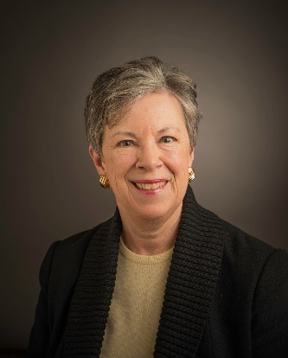
Class 1: What is the structure for food/agriculture/nutrition science policy in the U. S.
Class 2: Understanding the budget: The key to making policy change
Class 3: Science and diplomacy
Class 4: Evidence-based decision making
Class 5: Open science
Class 6: Scientific integrity policies
Class 7: National security policy and food, agriculture, and nutrition
Class 8: The biology revolution and science policy
Class 9: Sustainability
Class 10: Public trust in science

